DRAFT ENVIRONMENTAL REPORT
for the

Strategic Environmental Assessment of the Interreg Programme Slovenia-Hungary 2021-2027
1 February 2022

PREPARED BY: | Grants Europe Consulting Kft.  1055 Budapest, Balassi Bálint utca 25.  Tel.: +36 1 319-1790  Fax.: +36 1 319-1381  Website: www.grantseurope.eu
CONTRACTING AUTHORITY: | Government Office of the Republic of Slovenia for Development and European Cohesion Policy European Territorial Cooperation and Financial Mechanism Office  Cross-border Programmes Management Division  Kotnikova 5, 1000 Ljubljana  Slovenia
TITLE OF THE CONTRACT: | Elaboration of the Strategic Environmental Assessment (SEA) of the Interreg Programme Slovenia-Hungary 2021-2027
TENDER ID: | No 4302-42/2021-15
EXPERT TEAM: | Balázs Fehér, Project Leader  Mojca Hrabar, Key Expert
- Inception Report

Table of Contents
NON-TECHNICAL SUMMARY 5
Main characteristics of the Interreg Programme Slovenia-Hungary 2021-2027 5
Current environmental conflicts and problems in the programme area and the likely evolution thereof without implementation of the programme 8
Likely environmental effects of programme implementation 9
Recommended measures to protect environment, guidelines for lower hierarchy levels 11
Monitoring and Evaluation Plan 13
1. MAIN CHARACTERISTICS OF THE STRATEGIC ENVIRONMENTAL ASSESSMENT 16
1.1. Objective of the strategic environmental assessment 16
1.2. SEA process and its relationship with the Interreg Programme Slovenia-Hungary 2021-2027 16
1.3. Incorporation of comments and proposals made during the SEA process 18
2. MAIN CHARACTERISTICS OF THE INTERREG PROGRAMME SLOVENIA-HUNGARY 2021-2027 18
2.1. The analysed territory 18
2.2. Main objectives and actions of the Programme 19
2.3. Relationship with other relevant plans, programmes, and environmental protection objectives established in these documents 21
2.4. Internal consistency of the programme document 28
2.4.1. Contradictions between Chapter 1 and Chapter 2 of the programme documents 28
2.4.2. Internal consistency of the programme document 28
3. CURRENT STATE OF THE ENVIRONMENT IN THE PROGRAMME AREA AND THE LIKELY EVOLUTION THEREOF WITHOUT IMPLEMENTATION OF THE PROGRAMME 29
3.1. The environmental characteristics of the areas which are likely to be affected by the programme objectives 29
3.1.1. Landscape structure 29
3.1.2. Soil conditions 30
3.1.3. River basins and their water resources, water protection, water use 31
3.1.4. Natural values, protected areas, biodiversity 34
3.1.5. Cultural heritage 35
3.1.6. Climate characteristics, the impacts of climate change 36
3.1.7. Natural resources, energy potentials 36
3.1.8. Waste management 37
3.2. Relevant environmental conflicts and problems 38
3.3. Likely evolution of the environment without implementation of the Programme 39
4. LIKELY ENVIRONMENTAL EFFECTS OF PROGRAMME IMPLEMENTATION 39
4.1. Potential impacts on environmental systems 39
4.1.1. Soil 39
4.1.2. Air 41
4.1.3. Noise and vibration 42
4.1.4. Surface waters and groundwater, including protection areas and risk areas 44
4.1.5. Biodiversity, flora, fauna, habitats, Natura 2000 territories, nature reserves 46
4.1.6. Climate 48
4.1.7. Built environment, settlement surroundings, landscape and cultural heritage 51
4.1.8. Human health, and quality of life 53
4.1.9. Environmental consciousness 56
4.2. Summary of environmental impacts 57
5. RECOMMENDED MEASURES TO PROTECT ENVIRONMENT, GUIDELINES FOR LOWER HIERARCHY LEVELS 60
6. MONITORING AND EVALUATION PLAN 61

List of figures
Figure 1: Relationship between the SEA and programme development processes 17
Figure 2: The analysed territory of the IP SI-HU 2021-2027 18
Figure 3: Intervention logic of the IP SI-HU 2021-2027 21
Figure 4: Relationship between actions of the Programme and objectives of EU-level, national and regional strategies relevant from an environmental point of view 26
Figure 5: Synergies of actions from an environmental point of view 28
Figure 6: Programme area with the main cities and topography data. 30
Figure 7: Soil conditions of the Programme area 31
Figure 8: Surface water bodies in the Programme area 32
Figure 9: Groundwater bodies in the Programme area 33
Figure 10: Flood risk ares in Programme area 33
Figure 11: Transboundary UNESCO Biosphere Reserve 35
Figure 12: Change in waste generated per capita 37
Figure 13: Environmental impacts of the actions in IP SIHU 2021-2027 58
Figure 14: Recommended indicators and evaluation criteria for the assessment of the Programme’s environmental impacts 63

List of Abbreviations
EC | European Commission
EU | European Union
FAO | Food and Agriculture Organisation
GHG | Greenhouse gas
HU | Hungary
IP SI-HU 2021 - 2027 | Interreg Programme Slovenia – Hungary 2021-2027
ISO | Interreg Specific Objectove
NGO | Non-governmental Organisation
NUTS | Nomenclature of territorial units for statistics
PTF | Programming Task Force
SEA | Strategic Environmental Assessment
SI | Republic of Slovenia
SO | Specific Objective
TBR MDD | Transboundary Biosphere Reserve Mura-Drava-Danube
UN | United Nations
UNESCO | United Nations Educational, Scientific and Cultural Organization

NON-TECHNICAL SUMMARY

Main characteristics of the Interreg Programme Slovenia-Hungary 2021-2027
The programme area of the Interreg Programme Slovenia-Hungary 2021-2027 (hereinafter: IP SI-HU 2021-2027, or Programme) covers a territory of 10 627 km², homes for 962 thousand citizens.
The analysed area of the Programme on the Slovenian side includes two NUTS 3 regions, covers a territory of 3 507 km², giving home to 440 thousand people altogether:
- Pomurje region
- Podravje region

The analysed area of the Programme on the Hungarian side also includes two NUTS 3 regions (‘megye’), covers a territory of 7 120 km², giving home to 522 thousand people altogether:
- Vas megye (county)
- Zala megye (county)

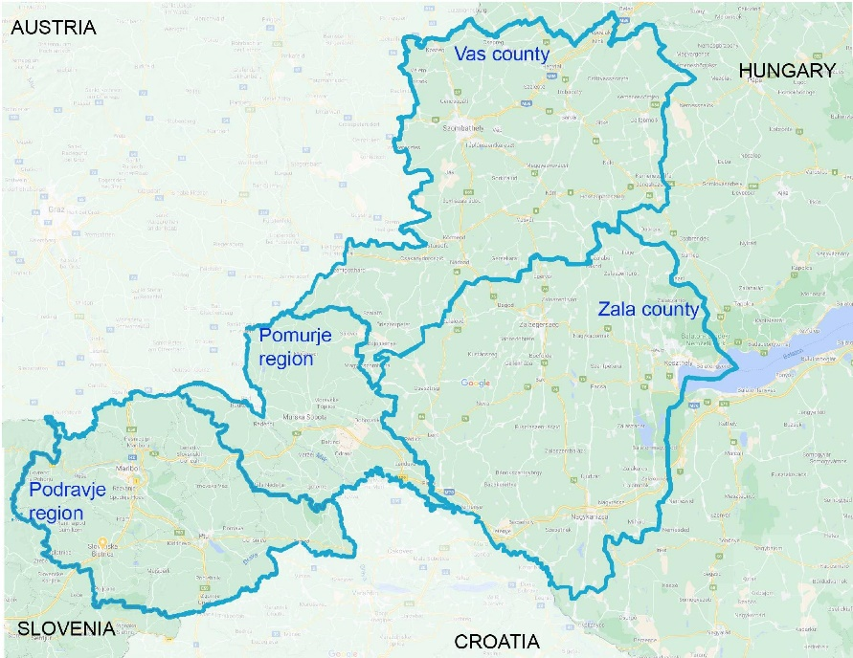
The analysed territory of the IP SI-HU 2021-2027
(Source: “Territorial and Socio-Economic Analysis, Interreg Programme Slovenia-Hungary 2021-2027”; 2021.)

Main objectives and actions of the Programme are as follows:
Priority | Specific Objective | Action
1.  Green border region | SO 2.7.  Enhancing protection and preservation of nature, biodiversity and green infrastructure, including in urban areas, and reducing all forms of pollution | - Elaboration of cross-border/common analytical studies, strategies, action plans and models for more effective preservation of natural assets, biodiversity and improvement or maintenance of natural assets  - Analysis water resources in terms of quantity and quality, development of monitoring system  - Research projects in the field of biodiversity, elaboration of cadastres of different species of flora and fauna and their presentation  - Common strategies on nature conservation and biodiversity  - Strategies and action plans for definition of joint measures of protection  - Strategies and action plans for introduction of sustainable ecosystem-based water management approaches, natural water retention measures in the border area, particularly on cross-border waterflows  - Improved spatial planning of urban areas and rural landscapes with focus on natural protection  - Modelling biodiversity impacts of climate change for the future and elaboration of pilots for testing possible solutions  - Elaboration of joint actions for management of nature-related disasters; strengthening the coordination role of municipalities therein  - Action plans for reduction of various forms of pollution (water, air, soil etc.).
1.2. Implementing joint pilot actions contributing to protecting biodiversity, fostering joint water and disaster management and reduction of pollution
- Joint actions improving biodiversity, cross-border ecological connectivity and green infrastructure
- Joint protocols, monitoring, intervention schemes for management of nature-related disasters
- Revitalisation, improvement of water quality of and sustainable management of cross-border waterflows, including testing and application of sustainable ecosystem-based water management approaches, natural water-retention measures in the border area
- Awareness raising and prevention activities on biodiversity, nature and environment protection, disasters (e.g. forest fires), fight against various forms of pollution

Priority | Specific Objective | Action
2.  Inclusive border region based on sustainable tourism | SO 4.6.  Enhancing the role of culture and sustainable tourism in economic development, social inclusion and social innovation | 2.1.Establishment of joint tourism quality standards and joint tourism destination management models on the basis of cooperation of tourism organisations  - Mapping and collection of existing quality standards  - Fostering establishment of joint quality cross-border tourism standards and brands  - Connection of micro tourism destinations to formulate cross-border tourism destination management systems  - Application of creative tools for attracting tourists and promotion, including innovative use of digital solutions and ICT tools  - Improvement the human capacity of local tourism sector (awareness raising actions, trainings)
2.2. Implementing pilot actions and joint solutions for development of quality tourism attractions and connected tourism services
- Quality improvement of cross-border tourism attractions with special focus on attractions of lesser-known areas
- Creation of joint cross-border tourism products and services focusing on integration of various tourism supply with cross-border relevance
- Improvement of cross-border accessibility of tourism attractions
3.  Cooperating border region | ISO 6.2  Enhance efficient public administration by promoting legal and administrative cooperation and cooperation between citizens, civil society actors and institutions, in particular with a view to resolving legal and other obstacles in border regions | 3.1. Enhance efficient public administration by promoting legal and administrative cooperation and cooperation between citizens, civil society actors and institutions, in particular with a view to resolving legal and other obstacles in border regions  - Elaboration of joint strategies to reduce legal and administrative obstacles of cooperation across the border  - Joint and coordinated spatial planning for easier development activities  - Joint cooperation activities in the field of low-carbon initiatives (energy efficiency, renewable energy, circular economy)  - Conceiving joint educational, vocational training programmes complementing/supporting official curricula with special emphasis on language education  - Joint skills development of the target groups and beyond  - Revealing and defining possibilities and fields of cross-border social and health care service cooperation  - Elaboration of joint strategies and action plans addressing social matters and a better integration of horizontal issues (e.g. gender equality and social inclusion, including youth, women and disabled)  - Creating and coordinating joint programs by the media in the border area to better inform the local population
 | ISO 6.3  Build up mutual trust, in particular by encouraging people-to-people actions | 3.2. Build up mutual trust, in particular by encouraging people-to-people actions  - Trust building activities of civil organisations in the field of arts and culture, sport, minorities, intercultural dialogue, inter-generational solidarity  - Organisation of various events with involvement of the target groups and the general public

Current environmental conflicts and problems in the programme area and the likely evolution thereof without implementation of the programme
Based on the situation analysis, the following main environmental conflicts and challenges can be identified in the programme area:
- The programme area has extensive green territories with significant natural values and high rate of biodiversity. However, human activities and climate change affect the entire ecosystem that needs mitigation actions.
- Extreme weather conditions, posing serious hydrological danger, occur more frequently as a consequence of climate change. The amount of precipitation days decreases, but that of days when a large amount of precipitation falls at once increases. As the soil is unable to absorb intense precipitation, surface run-off can significantly increase.
- The border region water management has particular challenges: low precipitation negatively affects ground water and surface water quantity, which, in combination with intensive agriculture, may reduce biodiversity.
- In the hilly and mountainous areas, which are the most prevalent in the area, there is a significant risk of erosion, which, in addition to climate change, is exacerbated by inappropriate cultivation and tillage practices.
- In the assessment according to the criteria of the Water Framework Directive, the physicochemical variables showed ‘Good’ status for Kebele stream and Lendava, and ‘Excellent’ for Kerka stream and Mura river. At the same time, during the assessment of the biological elements, all the mentioned watercourses can be said to be of medium status, so the ecological status of the watercourses could be improved in terms of the studied groups of organisms (especially macroscopic invertebrates and coating algae).
- The common specificity of this area are the geothermal waters. Overexploitation of thermal waters was recognised in the last years therefore more sustainable ways of using them are being promoted.
- Although the amount of waste generated per inhabitant per year in the two countries is lower than the EU average, both countries have seen an increase in recent years.
- Comparing Slovenia’s and Hungary’s waste management, it is clear that the share of treatment-types is similar: landfill and deposit treatment are the major ways of waste management, even if they show decreasing trend in both countries.

A lack of implementation of the Programme might cause effects of different orientation on the state of the environmental elements and systems.
- The lack of implementing the actions explicitly addressing environmental challenges (under priority “Green border region) may result in the persistence or possible escalation of existing environmental conflicts. Due to the fact that the Programme's environment-focused actions contribute the most to the preservation of natural and semi-natural habitats, biodiversity, as well as to protection of surface and ground water, the lack of planned developments would primarily have an adverse effect on these environmental systems. However, given the fact that a significant part of environmental development is directed at planning tasks, it is more appropriate to say that the lack of action reduces the chances of protecting environmental elements and systems.
- Contrary to the above, the absence of actions with an environmental risk, limited to tourism development within the Programme, would logically avoid environmental pressures arising potentially from this activity. However, due to the low level of associated environmental risks (see Chapter 4.1 of environmental report for details), the planned development of tourism is unlikely to have a significant impact on the state of the environment, i.e. the absence of these elements of the Programme would not result in significant environmental benefits.

Likely environmental effects of programme implementation
Based on the results of the environmental assessment performed, it can be concluded that the Programme includes relatively few actions with significant environmental impacts. This is mainly due to the limited number of intervention areas and infrastructure developments covered by the Programme.
At the same time, we welcome the fact that among the few intervention areas, the protection of the environment, nature and landscape is strongly represented. The vast majority of interventions aimed at reducing the exploiation of and pressure on environmental elements and systems, as well to improve the quality of human life, harmonized with environmental interests are included in the priority "Green Border Region". Some of the activities are of a planning and preparatory nature, i.e. they are aimed at developing action plans and strategies, developing montoring systems and implementing research programmes mainly for water management and nature conservation. Their importance for environmental protection and nature conservation is unquestionable, but it is almost impossible to assess precisely what impact they may have on the quantitative and qualitative status of individual environmental elements. As planning tasks, awareness-raising programmes can also play an important role. However, given that the environmental effectiveness of these actions is influenced by a number of external factors being independent from the Programme, only a moderate environmental impact has been attributed to such actions in the evaluation.
Within the entire Programme, the possibility of potentially resulting in an increased exploitation of and pressure on environmental elements and systems might come up in case of only one intervention, that is tourism development. It is well known that tourism can have unfavourable environmental effects, above all by raising the demand for transport, operating tourism facilities, disturbing natural, semi-natural habitats, flora and fauna. At the same time, the volume of developments that can be implemented during the Programme suggests that the Programme's tourism development actions will not lead to a large-scale use and stress on the environmental elements and systems, especially because they focus on increasing quality and supporting micro-tourism. However, a special attention will have to be paid on its prevention when implementing the Programme, for which several recommendations are provided by the current environmental report. Full implementation of those recommendations and their continuation in the future would ensure that no negative impact occur.
Finally, it is worth mentioning that many activities of the Programme are basically not related at all to the protection of environmental values. In particular, both actions under priority "Cooperating border region" fall into this category. But even in these cases, some activities can contribute, even if only locally, to the conservation of environmental elements and systems, in particular the built environment and cultural heritage elements (e.g. joint cooperation activities in the field of low-carbon initiatives, trust building activities in the field of culture).
Considering the expected impacts driven by the Programme on various environmental elements and systems, it can be concluded that surface and groundwater, as well as nature seem to be the most positively affected. A further positive environmental impact of the programme could be that its implementation could support the adaptation to the already unavoidable impacts of climate change. Climate adaptation aspects can be identified mainly in the activities on water management (see e.g. the emphasis on the importance of water retention), as well as in research on biodiversity conservation (modelling biodiversity impacts of climate change, elaboration of pilots for testing possible solutions), and in developments to improve protection against nature-related disasters. By implementing the Programme, the least progress is expected in the field of air pollution, as well as noise and vibration exposure prevention, which is, however, partly counteracted by the fact that these pressures are not considered to be significant in the programme area.
The table below summarizes the environmental impacts of each action presented in detail in the environmental report. The categories used are based on the Slovenian Decree laying down the content of environmental report and on detailed procedure for the assessment of the effects on certain plans and programmes on the environment (Uredba o okoljskem poročilu in podrobnejšem postopku celovite presoje vplivov izvedbe planov na okolje, Official Gazzette of Republic of Slovenia, no. 73/05)
Actions | Soil | Air | Noise, vibration | Water | Natural values | Climate | Built env., landscape | Human health | Env. con-sciousness
1.1.  Elaboration of cross-border/common analytical studies, strategies, action plans and models for more effective preservation of natural assets, biodiversity and improvement or maintenance of natural assets | A | A | A | A | A | A | A | A | A
1.2.  Implementing joint pilot actions contributing to protecting biodiversity, fostering joint water and disaster management and reduction of pollution | A | A | A | A | A | A | A | A | A
2.1.  Establishment of joint tourism quality standards and joint tourism destination management models on the basis of cooperation of tourism organisations | A | A | A | A | A | A | A | A | A
2.2.  Implementing pilot actions and joint solutions for development of quality tourism attractions and connected tourism services | B | A | B | B | B | A | X | X | A
3.1.  Enhance efficient public administration by promoting legal and administrative cooperation and cooperation between citizens, civil society actors and institutions, in particular with a view to resolving legal and other obstacles in border regions | A | A | A | A | A | A | A | A | A
3.2.  Build up mutual trust, in particular by encouraging people-to-people actions | A | A | B | A | A | A | A | A | A

Legend | A | no impact or positive impact on environmental objectives
 | B | the negative impact on environmental objectives is insignificant
 | C | the impact on environmental objectives is insignificant due to the implementation of mitigation measures
 | D | the negative impact on environmental objectives is significant
 | E | the negative impact on environmental objectives is devastating
 | X | the nature of the impact on environmental objectives cannot be determined

The results of the strategic environmental assessment carried out show that actions of the Programme are not expected to have any significant negative environmental impact due to their nature, i.e.:
- they DO NOT lead to significant greenhouse gas (GHG) emissions (climate mitigation);
- they DO NOT lead to an increased adverse impact of the current climate and the expected future climate, on the activity itself or on people, nature or assets (climate adaptation);
- they ARE NOT detrimental to the good status or the good ecological potential of bodies of water, including surface water and groundwater, or to the good environmental status of marine waters (sustainable use and protection of water and marine resources);
- they DO NOT lead to significant inefficiencies in the use of materials or in the direct or indirect use of natural resources, they DO NOT significantly increase the generation, incineration or disposal of waste, and the long-term disposal of waste may DO NOT cause significant and long-term environmental harm (circular economy, including waste prevention and recycling);
- they DO NOT lead to a significant increase in emissions of pollutants into air, water or land (pollution prevention and control);
- they ARE NOT significantly detrimental to the good condition and resilience of ecosystems, or detrimental to the conservation status of habitats and species, including those of Union interest (protection and restoration of biodiversity and ecosystems)
Overall, it can be concluded that actions of the Interreg Programme Slovenia-Hungary 2021-2027 would do no significant harm to environmental objectives within the meaning of Article 17 of Regulation (EU) No 2020/852” (“The Taxonomy Regulation”).

Recommended measures to protect environment, guidelines for lower hierarchy levels
As stated above, the implementation of the Programme is not expected to lead to a significant deterioration of the state of the environment. On the contrary, it will help to resolve and mitigate many existing environmental conflicts. Nevertheless, the implementation manner of the Programme plays a key role in achieving the positive environmental impacts. The following is a summary of our recommendations in this regard, grouped according to priorities of the Programme (justification of proposals is provided in Chapter 4.1 of the environmental report).
Priority | Recommendation
1.  Green border region | - It is suggested to include among the topics of environmental awareness raising the ways of clean domestic heating and avoiding the burning of duff  - Strategies and plans for protection of natural values, nature conservation and biodiversity to be developed under this action should also address the prevention and mitigation of noise and vibration exposure on wildlife.  - To maximise the positive impacts, it is proposed to implement green and blue infrastructure activities in a coordinated way (e.g. on the same site, based on a joint planning).  - It is proposed that the programme should also support preparatory activities for the designation of new protected areas.  - Strategies and action plans to be developed under the Programme should be based on projected climate conditions for the coming decades and pay particular attention to the possibilities for adaptation to them.  - It is proposed to add climate mitigation and adaptation (or in general, climate change related knowledge) to the target areas of awareness-raising activities.
2.  Inclusive border region based on sustainable tourism | - The Programme should emphasize that tourism can only be developed in an environmentally sustainable way.  - Tourism development should always consider the protection of ecological networks (core areas, ecological corridors, buffer zones). Pressures on protected areas should be avoided through appropriate siting of facilities and careful design of tourism products and services.  - The development of tourist services and attractions should avoid investments that require significant land take.  - During the implementation of the Programme, noise protection should also play a role in the design of tourism products and services (e.g. timing and location of events), taking into account also wildlife considerations.  - In case of the development of tourist facilities, it is proposed to maintain or establish several metres of native species vegetation along the banks of surface waters.  - During the implementation of the Programme, projects aimed at the development of tourism products, services and attractions should include some small-scale complementary measures to mitigate the environmental impacts of tourism (e.g., developing additional infrastructure (waste disposal facilities, toilets) to cope with increased visitor numbers; promotion of public transport accessibility; development of low volume cycling infrastructure etc.). The fact that the area covered by the Programme has a long tradition of cycling and active and eco-tourism makes this much easier to achieve.  - The design of tourism facilities must in all cases be largely adapted to the landscape and townscape,especially in cases where the object affected by the development is located at landmarks (e.g. lookout points). Cultural heritage aspects must be fully taken into account in the design.  - Among the target groups of the tourism services and products to be developed, it is proposed to include the population of the region (see promotion of regional and sub-regional tourism).
3.  Cooperating border region | -

Monitoring and Evaluation Plan
The analysis and assessment of the environmental and sustainability impacts of the Programme should be conducted primarily on the basis of data already recorded in existing databases and periodic monitoring reports. At the same time, it is essential to maintain a register of the main characteristics of environmentally relevant developments (especially infrastructure ones), that allows easier assignment of data available in national databases to the developments implemented in the framework of the Programme. These characteristics for infrastructural developments are the followings:
- exact location and extent of areas affected by a development, in ha or m²;
- land use classification of areas affected by a development;
- identification of potentially affected protected natural areas and Natura 2000 areas
It is recommended that all comprehensive evaluations of the Programme (mid-term and final) include a detailed assessment on the environmental, sustainability impacts of the Programme. It is however not necessary to cover all environmental elements or systems in these analyses, as the strategic environmental assessment has concluded that significant impacts are expected for only a few environmental systems, mainly due to the narrow intervention focus of the Programme. The analyses should focus on these. The impact of the implemented activities on environmental elements and the environmental performance of the programme should be analysed against the following indicators and evaluation criteria as part of the overall evaluation of the Programme.
Environ-mental system | Indicator/  evaluation criteria | Objective | Source of data and information | Relevant priority
Natural resources | Conservation status of habitat types and qualifying species in protected areas and/or Natura2000 sites affected by the activities of the Programme | good status | - Reports on the status of listed species and habitat types prepared in the framework of the monitoring of the implementation of the Birds Conservation Dirictive and Habitats Directives  - Reports on the implementation of projects  - National Forest Inventory Database in Hungary | - “Green border region”  - “Inclusive border region based on sustainable tourism”  (only for activities implemented in protected areas and/or Natura2000 sites)
Surface water | Percentage of surface water bodies with 'good' integrated status in the area covered by the activities under the Programme  (with supporting explanation of the chemical and ecological status of the surface water bodies concerned) | all water bodies in good condition | National River Basin Management Plans  Water quality monitoring system developed under the Programme | - “Green border region”  - “Inclusive border region based on sustainable tourism”
Cultural heritage | State of cultural heritage affected by the activities of the Programme | good condition | Reports on the implementation of projects | - “Inclusive border region based on sustainable tourism”
Climate change | Road traffic volumes on national roads in the municipalities concerned by tourism development | no increase, possibly decrease | National traffic counting data | - “Inclusive border region based on sustainable tourism”

In relation to the above indicators and focus areas to be analysed it needs to be considered that the limited financial resources available under the Programme are likely to result in localised, small-scale environmental impacts that might be difficult to detect, since the status of the above indicators is also influenced by circumstances independent of the Programme, in many cases to a greater extent than by the Programme itself. The evaluations should therefore always include a combined analysis of the project implementation reports and the data available independently of the Programme.

MAIN CHARACTERISTICS OF THE STRATEGIC ENVIRONMENTAL ASSESSMENT

Objective of the strategic environmental assessment
In accordance with Directive 2001/42/EC of the European Parliament and of the Council on the assessment of the effects of certain plans and programmes on the environment, main objectives of the strategic environmental assessment (hereinafter: SEA) are as follows:
- to describe and assess the likely significant effects on the environment of the programme implementation, which have to be taken into account in its preparation
- to provide relevant information to assess the environmental challenges and considerations which will help to ensure that environmental concerns are appropriately integrated in the decision-making and implementation processes of the programme
- to raise awareness for the potential environmental impact of envisaged activities among the programme partners
- to provide recommendations for adjustments of the programme thereby respecting the principle of proportionality
- to deliver all the documents in accordance with the necessary steps of the SEA in compliance with the relevant EU Directive as well as with the applicable national legislation of Slovenia and Hungary
The strategic environmental assessment is an integral part of the programming process, but for reasons of transparency, the outcomes of the SEA are published in a consolidated Environmental Report. However, although the Environmental Report is the main outcome of the environmental assessment, its most important goal is the continuous support of the process of Programme development.

SEA process and its relationship with the Interreg Programme Slovenia-Hungary 2021-2027
As mentioned above, most important goal of SEA is the effective support for programme development process. To achieve it, the SEA schedule has been aligned with the programming schedule to allow for effective communication between expert teams responsible for development of the Programme and SEA and to support the integration of environmental considerations into the Programme. The SEA experts formulated recommendations throughout the drafting of Chapter 2 of the Programme in an interactive way, maintaining close contact with the expert team responsible for planning during the whole SEA process.

The outcome of the SEA process is the draft environmental report, which is launched for consultation with national environmental authorities and the public in a way that allows incorporation of proposed amendments made to environmental report into the text of the Programme as well.
Finally, the environmental report will be approved as an integrated part of the Programme by the Programming Task Force and by the Governments of both Member States.
The figure below shows the relationship between the SEA and programme development processes.
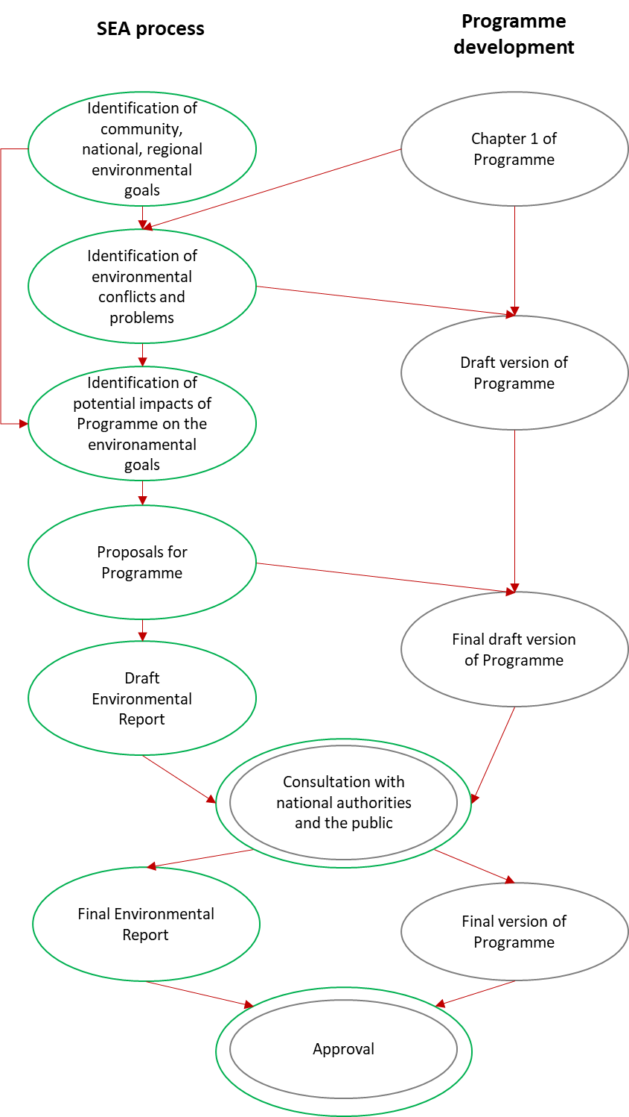
Figure 1: Relationship between the SEA and programme development processes

Incorporation of comments and proposals made during the SEA process
This chapter can be prepared in the last phase of SEA process, after conducting a public consultation and receiving the opinion of national environmental authorities of both Member States.

MAIN CHARACTERISTICS OF THE INTERREG PROGRAMME SLOVENIA-HUNGARY 2021-2027

The analysed territory
The programme area of the Interreg Programme Slovenia-Hungary 2021-2027 (hereinafter: IP SI-HU 2021-2027, or Programme) covers a territory of 10 627 km², homes for 962 thousand citizens.
The analysed area of the Programme on the Slovenian side includes two NUTS 3 regions, covers a territory of 3 507 km², giving home to 440 thousand people altogether:
- Pomurje region
- Podravje region

The analysed area of the Programme on the Hungarian side also includes two NUTS 3 regions (‘megye’), covers a territory of 7 120 km², giving home to 522 thousand people altogether:
- Vas megye (county)
- Zala megye (county)

Figure 2:: The analysed territory of the IP SI-HU 2021-2027
(Source: “Territorial and Socio-Economic Analysis, Interreg Programme Slovenia-Hungary 2021-2027”; 2021.)

Main objectives and actions of the Programme
The table below shows the intervention logic of the Programme.
Priority | Specific Objective | Action
1.  Green border region | SO 2.7.  Enhancing protection and preservation of nature, biodiversity and green infrastructure, including in urban areas, and reducing all forms of pollution | - Elaboration of cross-border/common analytical studies, strategies, action plans and models for more effective preservation of natural assets, biodiversity and improvement or maintenance of natural assets  - Analysis water resources in terms of quantity and quality, development of monitoring system  - Research projects in the field of biodiversity, elaboration of cadastres of different species of flora and fauna and their presentation  - Common strategies on nature conservation and biodiversity  - Strategies and action plans for definition of joint measures of protection  - Strategies and action plans for introduction of sustainable ecosystem-based water management approaches, natural water retention measures in the border area, particularly on cross-border waterflows  - Improved spatial planning of urban areas and rural landscapes with focus on natural protection  - Modelling biodiversity impacts of climate change for the future and elaboration of pilots for testing possible solutions  - Elaboration of joint actions for management of nature-related disasters; strengthening the coordination role of municipalities therein  - Action plans for reduction of various forms of pollution (water, air, soil etc.).
1.2. Implementing joint pilot actions contributing to protecting biodiversity, fostering joint water and disaster management and reduction of pollution
- Joint actions improving biodiversity, cross-border ecological connectivity and green infrastructure
- Joint protocols, monitoring, intervention schemes for management of nature-related disasters
- Revitalisation, improvement of water quality of and sustainable management of cross-border waterflows, including testing and application of sustainable ecosystem-based water management approaches, natural water-retention measures in the border area
- Awareness raising and prevention activities on biodiversity, nature and environment protection, disasters (e.g. forest fires), fight against various forms of pollution

Priority | Specific Objective | Action
2.  Inclusive border region based on sustainable tourism | SO 4.6.  Enhancing the role of culture and sustainable tourism in economic development, social inclusion and social innovation | 2.1. Establishment of joint tourism quality standards and joint tourism destination management models on the basis of cooperation of tourism organisations  - Mapping and collection of existing quality standards  - Fostering establishment of joint quality cross-border tourism standards and brands  - Connection of micro tourism destinations to formulate cross-border tourism destination management systems  - Application of creative tools for attracting tourists and promotion, including innovative use of digital solutions and ICT tools  - Improvement the human capacity of local tourism sector (awareness raising actions, trainings)
2.2. Implementing pilot actions and joint solutions for development of quality tourism attractions and connected tourism services
- Quality improvement of cross-border tourism attractions with special focus on attractions of lesser-known areas
- Creation of joint cross-border tourism products and services focusing on integration of various tourism supply with cross-border relevance
- Improvement of cross-border accessibility of tourism attractions
3.  Cooperating border region | ISO 6.2  Enhance efficient public administration by promoting legal and administrative cooperation and cooperation between citizens, civil society actors and institutions, in particular with a view to resolving legal and other obstacles in border regions | 3.1. Enhance efficient public administration by promoting legal and administrative cooperation and cooperation between citizens, civil society actors and institutions, in particular with a view to resolving legal and other obstacles in border regions  - Elaboration of joint strategies to reduce legal and administrative obstacles of cooperation across the border  - Joint and coordinated spatial planning for easier development activities  - Joint cooperation activities in the field of low-carbon initiatives (energy efficiency, renewable energy, circular economy)  - Conceiving joint educational, vocational training programmes complementing/supporting official curricula with special emphasis on language education  - Joint skills development of the target groups and beyond  - Revealing and defining possibilities and fields of cross-border social and health care service cooperation  - Elaboration of joint strategies and action plans addressing social matters and a better integration of horizontal issues (e.g. gender equality and social inclusion, including youth, women and disabled)  - Creating and coordinating joint programs by the media in the border area to better inform the local population
 | ISO 6.3  Build up mutual trust, in particular by encouraging people-to-people actions | 3.2. Build up mutual trust, in particular by encouraging people-to-people actions  - Trust building activities of civil organisations in the field of arts and culture, sport, minorities, intercultural dialogue, inter-generational solidarity  - Organisation of various events with involvement of the target groups and the general public
Figure 3: Intervention logic of the IP SI-HU 2021-2027
Source: own construction based on IP SI-HU 2021-2027

Relationship with other relevant plans, programmes, and environmental protection objectives established in these documents
The environmental assessment included an analysis of the relationship among actions of the Programme and environmentally relevant objectives of EU-level, national and regional strategies. We examined whether actions of the Programme support, jeoparadise, or do not affect the achievement of environmental or sustainability goals set in strategic documents. Please note that the analysis included only objectives of strategies that are relevant in the programme area.
Results of the analysis are summarized in the table below.

Environmental and/or sustainability objectives of the documents | Action
 | 1.1. | 1.2. | 2.1. | 2.2. | 3.1. | 3.2.
EUROPEAN UNION
European Green Deal
Increasing the EU’s climate ambition for 2030 and 2050 | 0 | 0 | 0 | ? | 0 | 0
Supplying clean, affordable and secure energy | 0 | 0 | 0 | 0 | 0 | 0
Mobilising industry for a clean and circular economy | 0 | 0 | 0 | 0 | 0 | 0
Building and renovating in an energy and resource efficient way | 0 | 0 | 0 | 0 | 0 | 0
A zero pollution ambition for a toxic-free environment | + | + | 0 | ? | 0 | 0
Preserving and restoring ecosystems and biodiversity | + | + | 0 | ? | 0 | 0
From “Farm to Fork”: a fair, healthy and environmentally friendly food system | 0 | 0 | 0 | 0 | 0 | 0
Accelerating the shift to sustainable and smart mobilty | 0 | 0 | 0 | 0 | 0 | 0
8th Environmental Action Programme (proposal)
Achieving the 2030 greenhouse gas emission reduction target and climate neutrality by 2050 | 0 | 0 | 0 | ? | 0 | 0
Enhancing adaptive capacity, strengthening resilience and reducing vulnerability to climate change | + | + | 0 | ? | 0 | 0
Advancing towards a regenerative growth model, decoupling economic growth from resource use and environmental degradation, and accelerating the transition to a circular economy | 0 | 0 | 0 | ? | 0 | 0
Pursuing a zero-pollution ambition, including for air, water and soil and protecting the health and well-being of Europeans | + | + | 0 | ? | + | +
Protecting, preserving and restoring biodiversity, and enhancing natural capital (notably air, water, soil, and forest, freshwater, wetland and marine ecosystems) | + | + | 0 | ? | 0 | 0
Reducing environmental and climate pressures related to production and consumption (particularly in the areas of energy, industrial development, buildings and infrastructure, mobility and the food system) | 0 | 0 | 0 | ? | 0 | 0
EU Biodiversity Strategy for 2030
Bringing nature back to agricultural land | 0 | 0 | 0 | 0 | 0 | 0
Addressing land take and restoring soil ecosystems | + | + | 0 | ? | 0 | 0
Increasing the quantity of forests and improving their health and resilience | + | + | 0 | ? | 0 | 0
Win-win solutions for energy generation | 0 | 0 | 0 | 0 | 0 | 0
Restoring freshwater ecosystems | + | + | 0 | ? | 0 | 0
Greening urban and peri-urban areas | + | + | 0 | 0 | 0 | 0
Reducing pollution | + | + | 0 | ? | 0 | 0
Addressing invasive alien species | 0 | 0 | 0 | 0 | 0 | 0
Improving knowledge, education and skills | + | + | 0 | 0 | 0 | 0
HUNGARY
National Framework Strategy on Sustainable Development of Hungary
Natural resources: Biodiversity, renewable natural resources | + | + | 0 | ? | 0 | 0
Natural resources: Reducing the environmental impact on human well-being | + | + | 0 | ? | 0 | 0
Natural resources: Rational use of non-renewable natural resources | 0 | 0 | 0 | 0 | 0 | 0
National Development and Territorial Development Concept of Hungary
Demographical change, healthy and renewable society | 0 | 0 | 0 | 0 | + | +
Sustainable use of our natural resources, preservation of our values and protection of our environment | + | + | 0 | ? | 0 | 0
Sustainable spatial structure based on regional potentials | + | + | 0 | ? | 0 | 0
National Climate Change Strategy of Hungary
Decarbonization | 0 | 0 | 0 | ? | 0 | 0
Adaptation and preparation | + | + | 0 | ? | 0 | 0
Ensuring a climate partnership | + | 0 | 0 | 0 | 0 | 0
National Energy and Climate Plan of Hungary
Decarbonization | 0 | 0 | 0 | ? | 0 | 0
Energy efficiency | 0 | 0 | 0 | 0 | 0 | 0
Energy security | 0 | 0 | 0 | 0 | 0 | 0
Research, innovation, and competitiveness | 0 | 0 | 0 | 0 | 0 | 0
National Water Strategy (Kvassay Jenő Plan) of Hungary
Water retention to make better use of our waters | + | + | 0 | 0 | 0 | 0
Preventive flood and inland water protection | + | + | 0 | 0 | 0 | 0
Gradual improvement of water quality until good status / potential is reached | + | + | 0 | ? | 0 | 0
High quality water utility service, implementation of rainwater management, with tolerable consumer load | 0 | 0 | 0 | 0 | 0 | 0
Improving the relationship between society and water (at individual, economic and decision-making levels) | + | 0 | 0 | 0 | 0 | 0
National Landscape Strategy of Hungary
Landscape utilization based on landscape features | + | + | 0 | ? | 0 | 0
Liveable landscape - liveable settlement - wise land use | + | + | 0 | ? | 0 | 0
Increasing landscape identity | + | 0 | 0 | 0 | 0 | +
Territorial development program of Vas County 2021-2030
A stable, crisis-resilient, competitive economy | 0 | 0 | 0 | + | 0 | 0
Liveable communities and improving environment | + | + | 0 | ? | + | 0
Growing knowledge capital | + | 0 | 0 | 0 | 0 | 0
Climate Change Strategy of Vas County
Reducing the county's GHG emissions | 0 | 0 | 0 | 0 | 0 | 0
Supporting the development of building energy action plans and measures | 0 | 0 | 0 | 0 | 0 | 0
Supporting the development of Sustainable Energy Action Programmes (SEAPs) of municipalities | 0 | 0 | 0 | 0 | 0 | 0
Support for GHG reduction measures in transport | 0 | 0 | 0 | ? | 0 | 0
Minimising the risks of heatwave periods | + | + | 0 | 0 | 0 | 0
Assessing the resilience of vulnerable natural habitats | + | 0 | 0 | 0 | 0 | 0
Enhancing the climate-proofing of residential buildings | 0 | 0 | 0 | 0 | 0 | 0
Reducing exposure of drinking water sources | 0 | 0 | 0 | 0 | 0 | 0
Reducing the risk of flash floods | + | + | 0 | 0 | 0 | 0
Developing tourism to take advantage of the potential of climate change | 0 | 0 | + | + | 0 | 0
Enhancing climate adaptation in agriculture | 0 | 0 | 0 | 0 | 0 | 0
Enhancing climate adaptation of forestry | 0 | 0 | 0 | 0 | 0 | 0
Mainstreaming climate protection in the practices of chambers and municipalities | 0 | 0 | 0 | 0 | 0 | 0
Territorial development program of Zala County 2021-2027
Improving the liveability of settlements: jobs, transport, services, built environment | 0 | 0 | 0 | + | 0 | 0
Protection of the natural environment | 0 | 0 | 0 | 0 | 0 | 0
Climate change Strategy of Zala County
40% reduction in emissions from buildings sector by 2050 compared to 2015 levels | 0 | 0 | 0 | 0 | 0 | 0
50% reduction in emissions from transport by 2050 compared to 2015 levels | 0 | 0 | 0 | ? | 0 | 0
20% reduction in emissions from agriculture by 2050 compared to 2015 levels | 0 | 0 | 0 | 0 | 0 | 0
60% reduction in emissions from waste management, including the wastewater sector, by 2050 compared to 2015 | 0 | 0 | 0 | 0 | 0 | 0
Protection and preservation of forest areas, planned afforestation and restoration of spontaneously afforested areas to maintain CO₂ absorption capacity | + | + | 0 | ? | 0 | 0
Maintaining the conservation status state of natural and semi-natural habitats under changing climatic conditions | + | + | 0 | ? | 0 | 0
Reducing the vulnerability of the main tourism attractions of the county | 0 | 0 | ? | ? | 0 | 0
Reducing the probability of water damage events | + | + | 0 | 0 | 0 | 0
Facilitate adaptation of agriculture to changing climatic conditions | 0 | 0 | 0 | 0 | 0 | 0
Mitigating the indirect impacts of climate change on human health | 0 | 0 | 0 | 0 | 0 | 0
Preservation of specific natural values threatened by climate change | ? | ? | 0 | ? | 0 | 0
Preservation of the wooden bell towers and folk architecture monuments, which are characteristic landscape features of the settlements in Zala, under extreme climatic conditions | 0 | 0 | 0 | ? | 0 | 0
REPUBLIC OF SLOVENIA
National Environment Protection Programme with programmes of measures until 2030
Protection, preservation and improvement of Slovenia's natural capital | + | + | 0 | 0 | ? | 0
Ensuring the transition to a low-carbon, resource-efficient, waste-preventing and efficient waste management society | 0 | 0 | 0 | ? | ? | 0
Protection of the population from environmental risks | + | + | 0 | 0 | 0 | 0
Operational Programme - Natura 2000 Site Management Program for the period 2015-2020 (based on Decree on special protection areas (Natura 2000 areas))
Maintaining or achieving a favorable status of plant and animal species and habitat types for which a Natura site is designated, with the following indicators indicating a favorable status | + | + | 0 | ? | 0 | 0
Preservation of the integrity of Natura sites in terms of preserving their ecological structures, functions and protection potential | + | + | 0 | ? | 0 | 0
Maintaining the connectivity of Natura sites | + | + | 0 | ? | 0 | 0
Draft Danube River Basin Management Plan for 2022-2027
Protection, improvement and restoration of surface water bodies in such a way as to achieve good ecological and chemical status of surface water in accordance with regulations governing environmental protection | + | + | 0 | ? | 0 | 0
Protection, improvement and restoration of groundwater bodies and ensuring balance during abstraction and remediation of groundwater so as to achieve its good chemical and quantitative status | + | + | 0 | ? | 0 | 0
Protection and improvement of all artificial and heavily modified water bodies in order to achieve good ecological potential and good chemical status of the water | ? | ? | 0 | 0 | 0 | 0
Reversal of any significant and sustained upward trend in the concentration of any pollutants in groundwater resulting from human activity and significantly endangering the quality of aquatic or terrestrial ecosystems, human health or human groundwater use | ? | ? | 0 | 0 | 0 | 0
Prevention or limiting of the introduction of pollutants into groundwater | + | + | 0 | 0 | 0 | 0
Gradual reduction of pollution by priority substances and cessation or phasing out of emissions, discharges and losses of priority hazardous substances both in surface waters and groundwater | 0 | 0 | 0 | 0 | 0 | 0
Ensuring protection against the harmful effects of water, mainly by reducing or preventing the risk of harmful effects of water and eliminating their consequences | + | + | 0 | 0 | 0 | 0
Mitigation of adverse effects of water use on the quantitative status of groundwater bodies (promotion of return pumped water in thermal aquifers) | ? | ? | 0 | 0 | 0 | 0
Eliminating excessive water use and promoting water reuse | ? | ? | 0 | ? | ? | 0
Mitigating the effects of droughts and floods | + | + | 0 | 0 | ? | 0
Raising public awareness of sustainable water use | + | + | 0 | ? | ? | 0
Strengthening inspections on water use and ensuring environmentally friendly flow | 0 | 0 | 0 | 0 | 0 | 0
Preservation or establishment of the natural equilibrium of water and riverbank/shore terrains (hydromorphological status, water regime, gravel formation, aquatic and riparian ecosystems) | ? | ? | 0 | 0 | 0 | 0
Ensuring appropriate hydrological and hydraulic conditions (protection against floods, erosion and landslides) | ? | ? | 0 | 0 | 0 | 0
The creation of maintenance programs that will follow the objectives, thus reducing the harmful effects | 0 | 0 | 0 | 0 | 0 | 0
Promotion of the development of blue-green infrastructure and green corridors | + | + | 0 | ? | 0 | ?
Flood Risk Management Plan for 2017-2021 period, and draft document for preparation of Flood Risk Management Plan for 2022- 2027
Avoiding new flood risks | + | + | 0 | 0 | 0 | 0
Reducing the existing flood risk | + | + | 0 | ? | 0 | 0
Reducing the existing flood risk during and after floods | + | + | 0 | 0 | 0 | 0
Raising awareness of flood risks | + | + | 0 | 0 | 0 | ?
Waste Management Programme and Waste Reduction Programme of the Republic of Slovenia
Prevention or reduction the harmful effects of waste generation and management (waste prevention, prevention of illegal dumping) | 0 | 0 | 0 | 0 | 0 | 0
A recycling society with a high level of efficiency of natural resource use, applying the priority order of waste prevention and management (waste hierarchy) and ensuring proper record keeping, tracking and analyzing of waste management data | 0 | 0 | 0 | 0 | 0 | 0
Ensuring Slovenia's independence in waste disposal and recovery of mixed municipal waste, with possibility of cooperation with other Member States due to the need for specialized processing plants for certain types of waste | 0 | 0 | 0 | 0 | 0 | 0
Resolution on the Slovenian climate long-term strategy 2050
Reducing GHG emissions and increasing abstractions by sinks | 0 | 0 | ? | ? | + | 0
Increased energy efficiency | 0 | 0 | ? | ? | + | 0
Increased use of enewable energy | 0 | 0 | ? | ? | + | 0
Draft Strategy of Spatial Development of Republic of Slovenia 2050
Rational and efficient spatial development | ? | 0 | 0 | 0 | + | 0
Competitiveness of Slovenian cities | 0 | 0 | ? | ? | 0 | 0
Quality life in urban and rural areas | ? | ? | ? | ? | + | +
Strengthening spatial identity and multifunctionality of space and adaptability to change | ? | ? | ? | 0 | + | 0
Cultural Heritage Strategy
Raising awareness of the social values of heritage | 0 | 0 | 0 | 0 | 0 | ?
Encouraging the involvement of individuals, communities and other stakeholders in heritage activities | 0 | 0 | 0 | ? | 0 | +
Improving access to heritage | 0 | 0 | 0 | + | 0 | ?
Achieving greater recognition of heritage in Slovenia and internationally | 0 | 0 | 0 | 0 | 0 | ?
Encouraging the diversified use and reuse of heritage and the exploitation of its potential | 0 | 0 | ? | ? | 0 | ?
Increasing the effectiveness of the legal and financial framework for heritage protection and preservation | 0 | 0 | 0 | 0 | 0 | 0
Ensuring greater capacity and efficiency of the public heritage protection sector and improving inter-ministerial cooperation | 0 | 0 | 0 | 0 | 0 | 0
Improving the quality of life by preserving heritage and promoting heritage activities | 0 | 0 | ? | ? | 0 | +
Raising the level of knowledge, skills and values related to heritage | 0 | 0 | 0 | 0 | 0 | +
Getting young people involved with heritage | 0 | 0 | 0 | 0 | 0 | +
Encouraging high-quality heritage research | 0 | 0 | 0 | 0 | 0 | ?
Integrating heritage into the information society | 0 | 0 | 0 | 0 | 0 | 0

Legend | + | Action of the Programme is in line with environmental/ sustainability objective
 | ! | Action of the Programme jeopardizes the achievement of the environmental/ sustainability goal
 | ? | Action’s impact on the environmental objective depends on the way of implementation
 | 0 | Action of the Programme and environmental/ sustainability objective are not related to each other

Figure 4: Relationship between actions of the Programme and objectives of EU-level, national and regional strategies relevant from an environmental point of view

Overall, the actions in the Programme support relatively few environmental and sustainability objectives, which is mainly due to the narrow intervention focus of the Programme. Of the environmental objectives set out in the various strategies, the Programme's actions will contribute most to the protection of surface water, groundwater, natural assets and biodiversity. On the basis of the information available under the Programme, the planned actions are not expected to prevent the achievement of any of the 'green objectives'.

Internal consistency of the programme document
Chapter 1 of the Programme, besides economic and social characteristics, also explores the environmental characteristics of the development area, and identifies the most important environmental conflicts. According to the planning logic, the objectives and actions of the Programme set out in the second chapter are aimed at resolving these.

Contradictions between Chapter 1 and Chapter 2 of the programme documents
Overall, the intervention logic of the Programme adequately reflects the environmental challenges identified in Chapter 1. Most of these, especially vulnerability of natural values, increasingly extreme weather conditions, water regime, and water balance and surface water quality problems are responded in a substantive manner by the relevant actions of the Programme under priority “Green border region”. Still, the Programme does not address all the environmental and sustainability challenges identified in the first chapter, which is due to its limited resources and relevantly, the necessity of focusing on the planned developments.

Internal consistency of the programme document
The internal synergy of the Programme was examined at the level of each action. The assessment seeked to clarify whether the individual actions together amplify the expected positive or possibly the adverse environmental impacts, further on, whether there are any of them that have conflicting environmental consequences. The results may differ in terms of the effects on different environmental elements. Therefore, for the sake of clarity, in the table below presenting the results of the assessments we have focused on the processes having the greatest impact.
Actions | 1.1. | 1.2 | 2.1. |  | 2.2 |  | 3.1. | 3.2.
1.1. |  | + | 0 |  | >< |  | 0 | 0
1.2. | + |  | 0 |  | >< |  | 0 | 0
2.1. | 0 | 0 |  |  | ! | + | 0 | 0
2.2. | >< | >< | ! | + |  |  | 0 | 0
3.1. | 0 | 0 | 0 |  | 0 |  |  | 0
3.2. | 0 | 0 | 0 |  | 0 |  | 0

Legend | + | Actions jointly contributing to a positive environmental impact
 | !! | Actions significantly and clearly contributing jointly to an adverse environmental impact
 | ! | Actions potentially causing some adverse but preventable environmental impacts
 | >< | Actions potentially causing contradictory environmental impacts
 | 0 | Actions not interrelated in terms of environmental impact
Figure 5: Synergies of actions from an environmental point of view
The main findings of the internal environmental consistency assessment of the Programme are the following:
- The document does not contain any actions whose simultaneous implementation would certainly lead to an increase in environmental conflicts.
- The two actions under priority "Green Border Region" reinforce each other's positive environmental effects, so it is advisable to implement them in parallel (i.e. to support at least partial implementation of the strategies developed under Action 1.1 under Action 1.2).
- The two tourism-themed actions may be able to amplify each other's environmental impacts, but the direction of the impact will be determined by the precise content of the actions (e.g. the combination of active tourism programmes that carefully integrate environmental considerations and creative tools that encourage them will lead to increased positive environmental impacts; while large-scale promotion of wellness spas by supporting smart solutions that encourage car access may lead to increased negative environmental impacts).
- The Programme also includes pairs of actions that could have opposite environmental effects. In practice, this small number of elements includes pairs of actions where one member supports tourism development and the other supports habitat and/or wildlife conservation activities. Again, the key problem is the potential - but largely avoidable - negative environmental impacts of tourism development, which are discussed in more detail in Chapter 4.1.

CURRENT STATE OF THE ENVIRONMENT IN THE PROGRAMME AREA AND THE LIKELY EVOLUTION THEREOF WITHOUT IMPLEMENTATION OF THE PROGRAMME
This chapter has been completed based on section 2. of the Territorial analysis.

The environmental characteristics of the areas which are likely to be affected by the programme objectives

Landscape structure
The spatial structure of the Slovenia-Hungary programme area is shown on Figure 6. As it is seen from the map the border area is characterised by urbanised areas and a relatively large share of protected areas (national and Natura 2000). The landscape is also relatively varied: flat areas combined with hilly terrain.
Both countries are quite centralised with the capitals as the main decision-making centres are located in the geographical centres of the countries. Both programme country areas are located relatively far away from the national capitals and main country’s transport nodes adding to the isolation of this region. Although the regions and counties of the Hungarian-Slovenian border area are similar in economic structure, they differentiate in some other characteristics. However, both the more touristic and cultural areas (e.g. thermal spas), as well as the typically rural areas and, are struggling with the disadvantages arising from the peripheral nature of border areas: ageing and declining population, low levels of entrepreneurial spirit and initiative, innovation, economic grouping and networking.
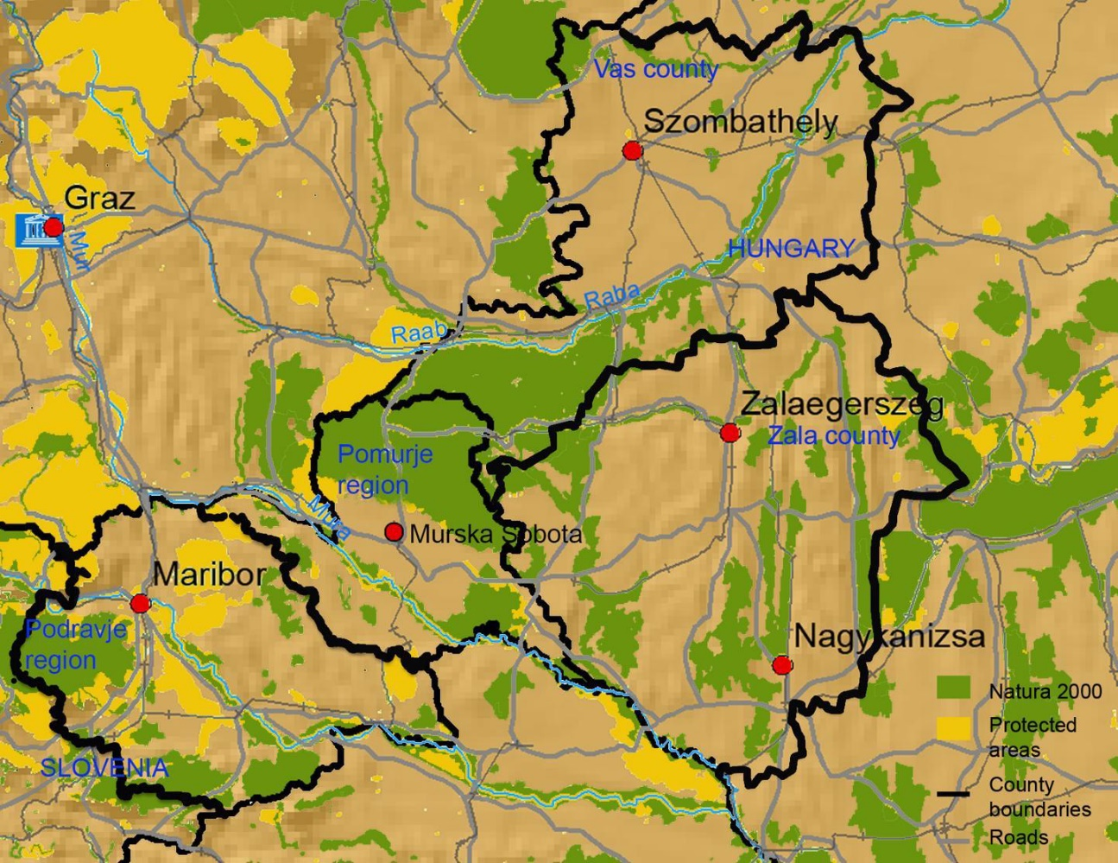
Figure 6: Programme area with the main cities and topography data.
(Source: Territorial and socio-economic analysis Interreg Programme Slovenia-Hungary, 2021)

Soil conditions
The soil conditions in the area covered by the Programme are highly variable, depending on the topography and hydrology of the area, as illustrated by the FAO soil map below.
In the hilly and mountainous areas, which are the most prevalent in the area, there is a significant risk of erosion, which, in addition to climate change, is exacerbated by inappropriate cultivation and tillage practices.
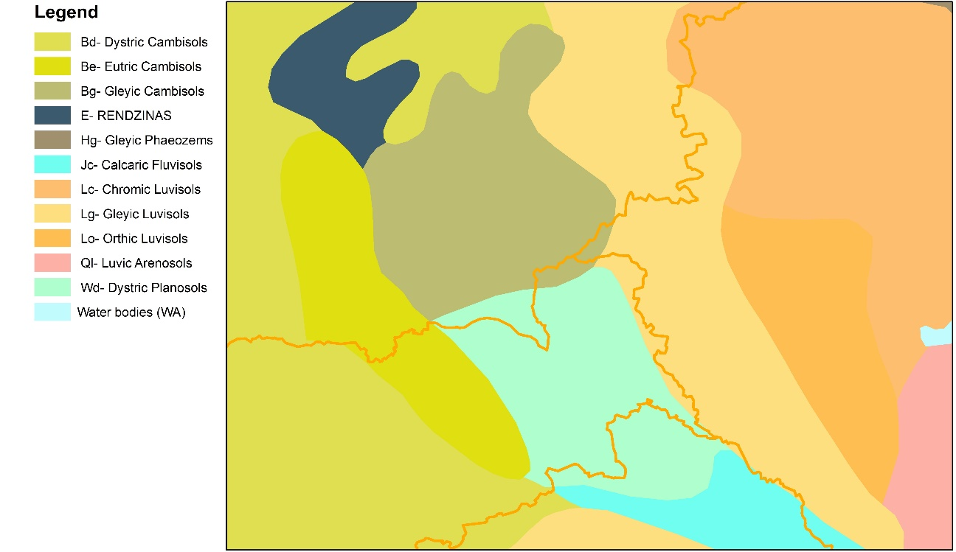
Figure 7: Soil conditions of the Programme area
(Source: FAO)

River basins and their water resources, water protection, water use
Slovenia is rich in water resources, although they are not spatially uniformly distributed. Water covers about 272 km² of Slovenia’s territory and most of it is in a good ecological state. Water quality is impacted especially by agriculture, so great attention is paid to agro-environmental measures. In comparison to the previous period, significant improvements have been carried out in the field of water management. In recent years, numerous municipal treatment facilities have been constructed, and some are still being built. More than half of the population’s wastewater is treated in municipal or communal facilities.
In terms of water supply Hungary strongly depends on river outflow from other countries: 95% of the surface waters are of foreign origin. One of the serious consequences of the climate change in the country is that less water is available for an increased water demand, especially for irrigation. From a strategic point of view impacts of climate are an additional negative element added to the already existing problem of water shortage. The total water abstraction in Hungary at present is about 6,000 million m³/year, thereof 75% for industrial use - cooling water. For the remaining part, the public is the major user with 40%, industry takes a little more than one quarter and agriculture uses the rest. 75% of the total abstraction (except for cooling water) is from groundwater. Besides the traditional dominance of groundwater in drinking water supply (94%), abstraction of groundwater for industry and for irrigation has been gradually increasing, and nowadays it exceeds the amount used from surface water (Somlyódy, Simonffy, 2004). This new situation may lead to non-sustainable exploitation.
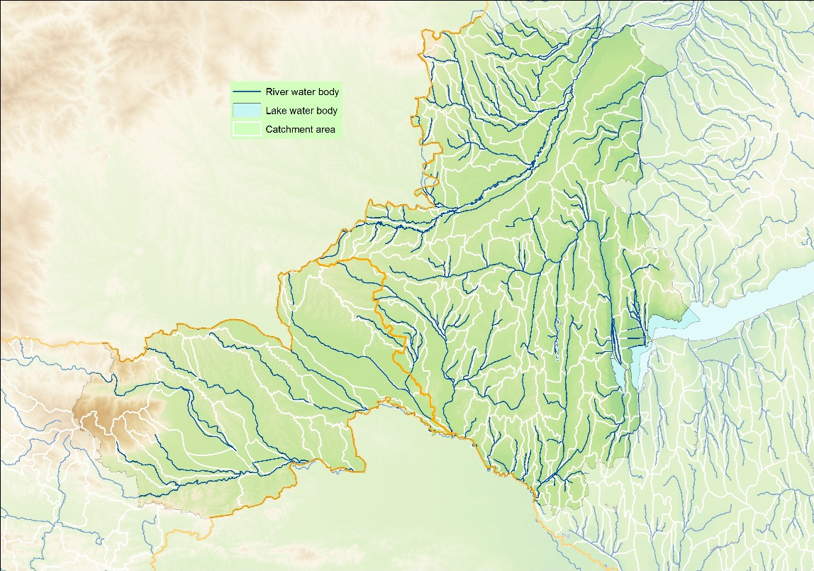
Figure 8: Surface water bodies of the Programme area
(Source: own construction based on data available at evode.gov.si and vizugy.gov.hu)
In the Slovenian-Hungarian border region, the water quality status of cross-border watercourses in Hungary are very favourable in terms of water chemistry. In the assessment according to the criteria of the Water Framework Directive, the physicochemical variables showed ‘Good’ status for Kebele stream and Lendava, and ‘Excellent’ for Kerka stream and Mura river.
At the same time, it must be said that during the assessment of the biological elements, all the mentioned watercourses can be said to be of medium status, so the ecological status of our watercourses could be improved in terms of the studied groups of organisms (especially macroscopic invertebrates and coating algae). (Source: Western Transdanubia Water Directorate).
As a result of relative low precipitation, the groundwater recharge in Pomurje and Podravje is among the weakest in Slovenia that is why the share of abstraction from available groundwater relative to available groundwater is relatively high in these two regions. Besides, relatively large amount of water is used for irrigation as this is agriculturally intensive area. Because of all of these factors, water bodies in the north-eastern part of Slovenia are the most polluted, namely in aquifers with predominantly inter granular porosity. In 2018, poor chemical status was found for the Savinjska, Drava and Mura basins. (Regional development program Podravje 2021-2027, draft). The Mura has the worst ecological status among bigger Slovenian rivers.

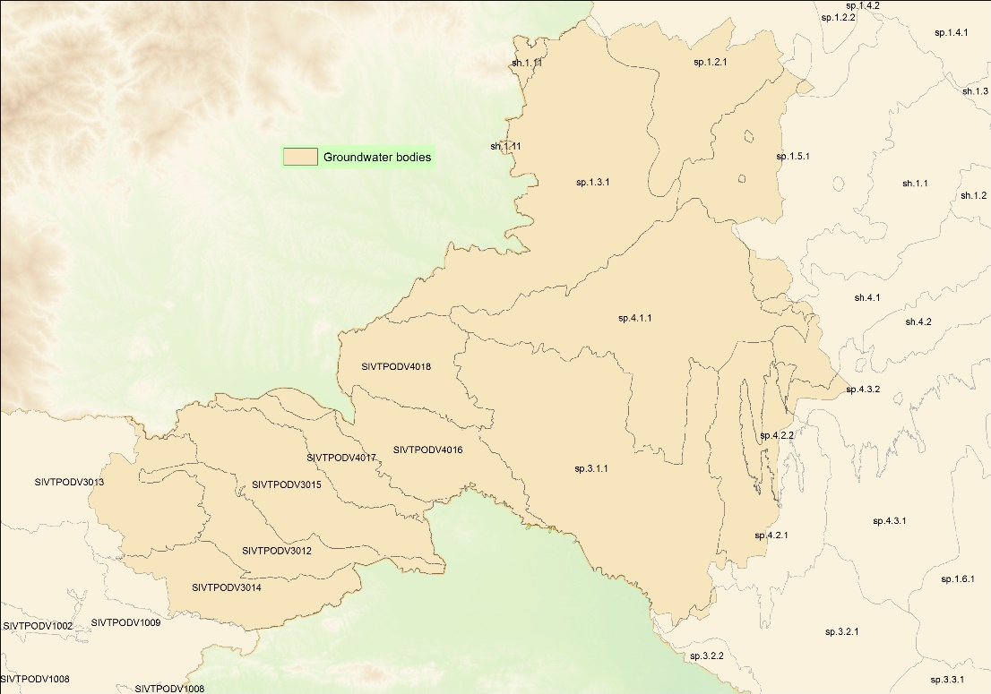
Figure 9: Groundwater bodies of the Programme area
(Source: own construction based on data available at evode.gov.si and vizugy.gov.hu)
Due to the topography and hydrology of the area (see the steep slopes of a large part of the Programme area and areas upstream of it, as well the uneven flow of the Drava and Mura rivers), floods occur regularly in the Programme region, including flash floods in the hilly areas. However, in the case of smaller watercourses, the construction of reservoirs in recent decades has reduced the flood risk locally. Nevertheless, the risk of flooding remains a major challenge for natural disaster management in the border region, especially on the Slovenian side.

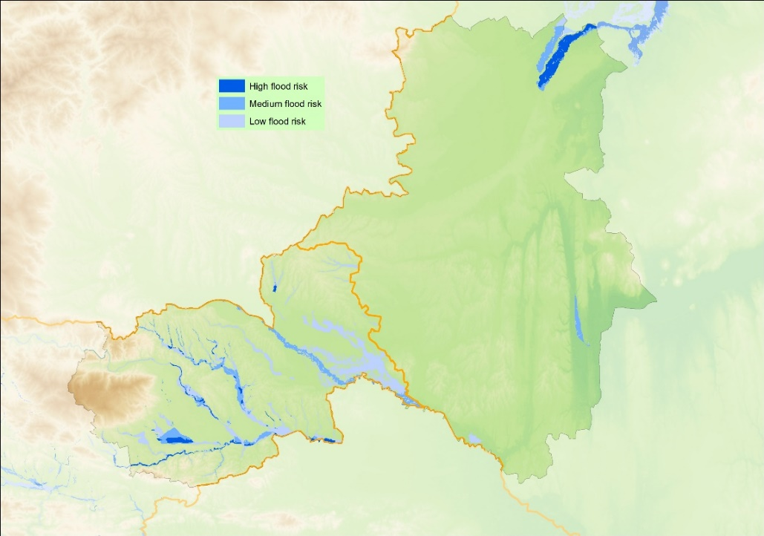
Figure 10: Flood risk ares in the Programme area
(Source: own construction based on data available at evode.gov.si and vizugy.gov.hu)

Natural values, protected areas, biodiversity
The Programme area is rich in environmental resources and natural values including diverse flora and fauna resulting in rich biodiversity to be protected.
In Slovenia, protected natural areas cover 12,5 % of the country surface and include one national park, three regional parks and 73 landscape parks. Moreover, 37% (7,683 km²) of the country’s territory is protected under Natura 2000, which is the highest percentage of national territory of all EU Member States.
- In Pomurje, 46% of the region’s territory (596,9 km2) is under Natura 2000. It covers the main protected territory of the Slovenian part of the Programme area, the picturesque Goričko Landscape Protection Park with a centre in the Grad castle. 96% of its territory is under Natura 2000 protection. The whole valley part of the pristine Mura river is under Natura protection as well.
- In Podravje 28% of the region’s territory (611.5 km2) in under Natura 2000. It covers the protected areas along Drava valley, mountain massif of Pohorje and Boč – Donačka mountain Nature park. In the urban environment the protected Lake of Maribor provides a series of ecosystem services for Maribor inhabitants and its visitors.
A review of the state of the natural and semi-natural habitats has shown that those habitat types are most at risk in the Slovenian part of programme area:
- Flowing waters and associated wetlands (Mura, Drava)
- Dry grasslands (Goričko)
The total Natura 2000 coverage amount to 21% of the territory of Hungary. In Hungary 10 national parks and several national landscape parks ensure the protection of the main natural values. Within the Programme area, Vas county contains 71, Zala county 79 protected areas out of the total 1195 local protected areas of the country. Three national parks cover partly the territory of the Programme area:
- In Vas county, the Őrség National Park and Fertő-Hanság National Park (only a very small part of it is located in the Vas county) cover the main protected areas, besides numerous landscape parks and local protected areas. Natura 2000 covers 21% of the territory. The total territory of the Őrség National Park is under Natura 2000 protection due to its special birdlife.
- In Zala county, the Balaton Uplands National Park with a territory of 57 ha is the most important protected area. Kis-Balaton is also protected by the international Ramsar Convention, serving the protection of wetland habitats and having tourism potential. However, only small western part of the Balaton is located in Zala county. The valley of the Mura River is a valuable habitat as well. The county has 258 settlements, out of which 42 has protected area on its territory. Natura 2000 covers 22% of the territory.
An important part of natural protection is also the 5-country Transboundary UNESCO Biosphere Reserve Mura-Drava-Danube, which combines the cluster of thirteen protected areas along the Mura-Drava-Danube region. The Biosphere Reserve in the programme area stretches along the Mura river, covering significant territories in Pomurje and Zala county.
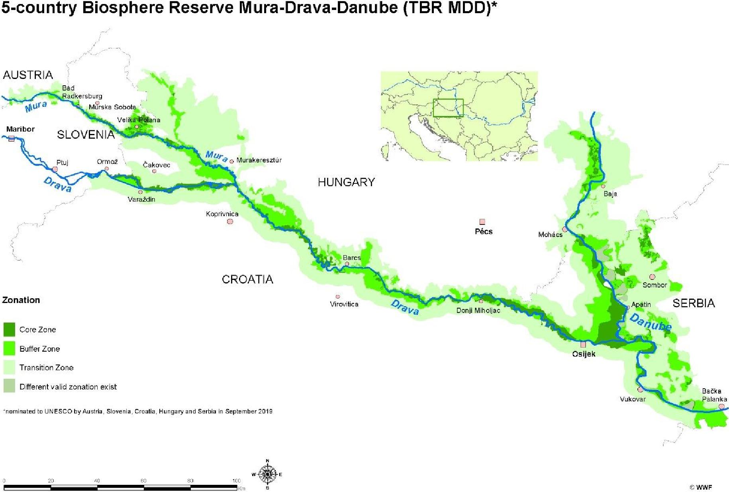
Figure 11: Transboundary UNESCO Biosphere Reserve
(Source: Territorial and socio-economic analysis Interreg Programme Slovenia-Hungary, 2021)

Cultural heritage
In terms of UNESCO-protected world cultural heritage, the border area is included in the Intangible Cultural Heritage of Humanity item “Door-to-door rounds of Kurenti”, which is a tradition of the area in Ptuj, celebrated in the carnival period. Being a living tradition, there are many Kurenti associations in the area, moreover it is included in education of kindergartens and elementary schools. On the tentative list of UNESCO World Heritage since 2017 the Balaton Uplands Cultural Landscape is included, which covers the north coast of the Lake Balaton, including the Lake Hévíz, the Festetics Castle of Keszthely with its park, the historic building of the Georgikon Farm that are located in Zala county, being also among the most significant tourism magnets of the Hungarian side. The Hungarian side of the border area is rich in traditional rural heritage buildings – most well-known are the objects in Göcsej and the Őrség – which is also included in the tentative list since 2017.
Beyond world heritage items it is worth to point out the nationally and regionally significant heritage elements, which are bases of the border area’s image and important foundation of the tourism attractions. The most important sites in regional breakdown:
- Podravje: the City of Maribor (including natural, built and sacral heritage), Ptuj (the oldest town of Slovenia), the Ormož castle, winemaking tradition concentrated in Jeruzalem and it surroundings;
- Pomurje: the historic centres of Murska Sobota and Lendava, Grad na Goričkem (the largest baroque castle in Slovenia), the Romanesque rotunda in Selo, pottering culture of Dobrovnik and Ljutomer, wine making in the area of Lendava, the numerous lakes in the region;
- Vas county: the urban centres of Szombathely, Szentgotthárd, Körmend (castle), the Őrség area (Őriszentpéter and the surrounding villages), the Ják Church, pottering culture of Magyarszombatfa;
- Zala county: rural architecture of Göcsej, the Hetés ethnographic area, rural churches and belfries, the bunker of Lovászi, natural and industrial heritage in the area of Bázakerettye, the Kis-Balaton reserve, the numerous lakes in the county.

Climate characteristics, the impacts of climate change
According to the forecast, years affected by drought will increase on both the Hungarian and the Slovenian side. The frequency of droughts increased in the inspected areas over the 50 years between 1962 and 2011. Extreme droughts have become more and more frequent in the second half of the period, besides the increasing trend. Between 1901 and 2016, extremities regarding warm temperature increased and extremities regarding cold temperature decreased because of climate change.
Water scarcity and aridification will not only become more frequent and prolonged, it will also affect the natural environment, natural resources, and agricultural forestry production bases. They also draw attention to the increasing uncertainties of the population’s water and food supply and the deteriorating quality of drinking water and food ingredients, while production costs and the risks of corporations and investors increase. Since these risks and challenges are of a regional nature, a close cross-border cooperation is needed to solve the problems.
Extreme weather conditions, posing serious hydrological danger, occur more frequently as a consequence of climate change. The amount of precipitation days decreases, but that of days when a large amount of precipitation falls at once increases. This tendency affects the forestry and agricultural sector negatively on both sides of the border, damages soil erosion and flood control systems, and as the soil is unable to absorb intense precipitation, surface run-off can significantly increase. The extremely severe storms and hails are becoming increasingly common environmental phenomena, and they are posing significant risks to agricultural production.
A further consequence of climate change is the increased frequency and severity of floods in the warmer and wetter water period. The risk of floods can also be increased by factors like the mismanagement of floodplains, mud silting up or the incapacity of protection systems. Overall, the annual water balance shows a decreasing trend in the region regarding both surface and groundwater.

Natural resources, energy potentials
The common specificity of this area are the geothermal waters.
Hungary is well known for its richness in thermal waters. A large part of them is recognised as world-famous mineral and thermal waters with a favourable composition and therefore are under protection. The Western Transdanubian Region is one of the most popular health tourism destination of the country due to its rich thermal water resources. The most well-known area is the lake of Hévíz, with a significant healing effect, providing traditional medical and healing wellness treatments. Further thermal spas and wellness facilities are available, among others, in Zalakaros, Sárvár, Bük and Lenti. Geothermal energy is used also for heating in spa facilities.
In Pomurje and Podravje geothermal energy is used primarily for heating and bathing. There are six thermal spas and health resorts, and an additional four recreation centres (three of them as part of hotels) where swimming pools are directly or indirectly heated by geothermal energy. The main thermal spas are located in Moravske Toplice, Murska Sobota, Banovci and Ptuj. Increasingly, geothermal energy is used for heating of greenhouses for highly specialised horticulture.
Overexploitation of thermal waters was recognised in the last years therefore more sustainable ways of using them are being promoted. Besides, the tourism is trying to move the main focus from the spas to other attractions in the rural areas.

Waste management
Although the amount of waste generated per inhabitant per year in the two countries is lower than the EU average, both countries have seen an increase in recent years. Slovenia started from a much higher base, with an average of 2500 kg/person of total waste generated per year until 2016, but reached 4000 kg/person in 2018. Hungary managed to reduce it to 1300 kg/person by 2010, but since then it has been increasing, exceeding 1700 kg/person in 2018.
The largest increase in Hungary is in construction and demolition waste. This fraction shows a similar increase in Slovenia. For Slovenia, the other significantly increasing component is soil. It can be concluded that the increase in waste in both countries is mainly related to the increasing performance of the construction industry.

Figure 12: Change in waste generated per capita
(Source: EUROSTAT)
Comparing Slovenia’s and Hungary’s waste management, it is clear that the share of treatment-types is similar: landfill and deposit treatment are the major ways of waste management, even if they show decreasing trend in both countries. Slovenia is stronger in recycling rate 58% and Hungary is weaker at rate 35% compared to rate of EU 46%. Recycling rates indicate the percentage of municipal waste generated that is recycled, composted and anaerobically digested, and might also include that prepared for reuse. Hungary has much higher rate of waste originated from households, 73% in 2014 and in Slovenia 12% in 2018.

Relevant environmental conflicts and problems
Based on the above, the following main environmental conflicts and challenges can be identified in the Programme area:
- The programme area has extensive green territories with significant natural values and high rate of biodiversity. However, human activities and climate change affects the entire ecosystem that needs mitigation actions.
- Extreme weather conditions, posing serious hydrological danger, occur more frequently as a consequence of climate change. The amount of precipitation days decreases, but that of days when a large amount of precipitation falls at once increases. As the soil is unable to absorb intense precipitation, surface run-off can significantly increase.
- The border region water management has particular challenges: low precipitation negatively affects ground water and surface water quantity, which, in combination with intensive agriculture, may reduce biodiversity.
- In the hilly and mountainous areas, which are the most prevalent in the area, there is a significant risk of erosion, which, in addition to climate change, is exacerbated by inappropriate cultivation and tillage practices.
- In the assessment according to the criteria of the Water Framework Directive, the physicochemical variables showed ‘Good’ status for Kebele stream and Lendava, and ‘Excellent’ for Kerka stream and Mura river. At the same time, during the assessment of the biological elements, all the mentioned watercourses can be said to be of medium status, so the ecological status of the watercourses could be improved in terms of the studied groups of organisms (especially macroscopic invertebrates and coating algae).
- The common specificity of this area are the geothermal waters. Overexploitation of thermal waters was recognised in the last years therefore more sustainable ways of using them are being promoted.
- Although the amount of waste generated per inhabitant per year in the two countries is lower than the EU average, both countries have seen an increase in recent years.
- Comparing Slovenia’s and Hungary’s waste management, it is clear that the share of treatment-types is similar: landfill and deposit treatment are the major ways of waste management, even if it they show a decreasing trend in both countries.

Likely evolution of the environment without implementation of the Programme
The lack of implementation of the Programme might cause effects of different orientation on the state of the environmental elements and systems.
The lack of implementing the actions explicitly addressing environmental challenges (under priority “Green border region) may result in the persistence or possible escalation of existing environmental conflicts. Due to the fact that the Programme's environment-focused actions contribute the most to the preservation of natural and semi-natural habitats, biodiversity, as well as to protection of surface and ground water, the lack of planned developments would primarily have an adverse effect on these environmental systems. However, given the fact that a significant part of environmental development is directed at planning tasks, it is more appropriate to say that the lack of action reduces the chances of protecting environmental elements and systems.
Contrary to the above, the absence of actions with an environmental risk, limited to tourism development within the Programme, would logically avoid environmental pressures arising potentially from this activity. However, due to the low level of associated environmental risks (see Chapter 4.1 for details), the planned development of tourism is unlikely to have a significant impact on the state of the environment, i.e. the absence of these elements of the Programme would not result in significant environmental benefits.

LIKELY ENVIRONMENTAL EFFECTS OF PROGRAMME IMPLEMENTATION

Potential impacts on environmental systems

Soil
None of the interventions in the Programme have been identified as potentially leading to permanent and significant pressures on soils. The document defines the soils as an important natural resource of Programme area, and several activities are therefore aimed at protecting and improving them, in particular through planning and awareness-raising. Several activities, although not targeted, also have a positive impact on soils, including interventions to improve groundwater and surface water status and to develop green infrastructure.
- Actions with no impact on soil
- 2.1. Establishment of joint tourism quality standards and joint tourism destination management models on the basis of cooperation of tourism organisations
- 3.1. Enhance efficient public administration by promoting legal and administrative cooperation and cooperation between citizens, civil society actors and institutions, in particular with a view to resolving legal and other obstacles in border regions
- 3.2. Build up mutual trust, in particular by encouraging people-to-people actions
- Actions with likely positive effect on soil conditions
Specific objective / Action | Likely positive impact on environmental system
1.1.  Elaboration of cross-border/common analytical studies, strategies, action plans and models for more effective preservation of natural assets, biodiversity and improvement or maintenance of natural assets | Likelihood of the impact | Duration and frequency of the impact | Reversibility of the impact | Geographical scope of the impact
 | low | lasting | reversible | regional
 | The action also includes an activity aimed directly at improving soil condition: developing action plans to reduce pollution (including soil). Most of the other measures may also have an indirect impact on soil condition, by improving the water balance and physical characteristics of the area's soils, increasing biodiversity, which may improve soil organic matter content, etc. However, it is important to stress that the actual positive effects expected from the activities supported under this action are uncertain, as they depend on the implementation of the strategies and plans developed under the action.
1.2.  Implementing joint pilot actions contributing to protecting biodiversity, fostering joint water and disaster management and reduction of pollution | Likelihood of the impact | Duration and frequency of the impact | Reversibility of the impact | Geographical scope of the impact
 | medium | lasting | reversible | regional
 | Similar to Action 1.1, a positive impact is expected through the improvement of biodiversity and soil water balance, but the magnitude of the impact may be higher than in Action 1.1, as the action includes concrete interventions, not "only" planning and preparation activities.
- Actions with adverse effect on soil
None of the actions

- Actions potentially also causing adverse effect on soil
Specific objective / Action | Potential negative impact on environmental system
2.2.  Implementing pilot actions and joint solutions for development of quality tourism attractions and connected tourism services | Likelihood of the impact | Duration and frequency of the impact | Reversibility of the impact | Geographical scope of the impact
 | low | lasting | reversible | local
Development of tourist attractions can result in pressure on the soils if the intervention generates a significant increase in visitor numbers and motorised traffic. Additional pressures may arise if activities are carried out in previously less visited areas, as mentioned in the action. All the natural resources, including soils, in the areas that have hitherto been less stressed should be protected and their stress avoided.
Recommended measures:
- The development of tourist services and attractions should avoid investments that require significant land take.

Air
Based on the assessment carried out, no action under the Programme can be identified that would have an adverse effect on air quality. On the contrary, support is also given to activities that have the potential to reduce air pollutant emissions and air pollution, even though their primary objective is not to protect air quality. These include strategic planning and awareness-raising activities aimed at preventing pollution of various kinds, and activities aimed at protecting natural assets, in particular vegetation.

A) Actions not affecting air quality
- 2.1. Establishment of joint tourism quality standards and joint tourism destination management models on the basis of cooperation of tourism organisations
- 2.2. Implementing pilot actions and joint solutions for development of quality tourism attractions and connected tourism services
- 3.1. Enhance efficient public administration by promoting legal and administrative cooperation and cooperation between citizens, civil society actors and institutions, in particular with a view to resolving legal and other obstacles in border regions
- 3.2. Build up mutual trust, in particular by encouraging people-to-people actions

- Actions with a likely positive impact on air quality
Specific objective / Action | Likely positive impact on environmental system
1.1.  Elaboration of cross-border/common analytical studies, strategies, action plans and models for more effective preservation of natural assets, biodiversity and improvement or maintenance of natural assets | Likelihood of the impact | Duration and frequency of the impact | Reversibility of the impact | Geographical scope of the impact
 | low | lasting | reversible | regional
 | Although the focus of the action is not on protecting air quality, the protection of this environmental element is also mentioned as a possible target area for action plans for reduction of various forms of pollution, which is certainly welcome. Spational planning of urban areas with a focus on protecting natural assets, through the development of green spaces, can also contribute to improving air quality in urban areas. However, the scale of the expected positive effects is determined by the fact that the programme supports preparatory activities, and the actual impact will depend on the implementation of the strategies and plans developed and on the use of research results.
1.2.  Implementing joint pilot actions contributing to protecting biodiversity, fostering joint water and disaster management and reduction of pollution | Likelihood of the impact | Duration and frequency of the impact | Reversibility of the impact | Geographical scope of the impact
 | low | lasting | reversible | regional
In contrast to Action 1.1, air quality protection is not mentioned in the description of this action. Nevertheless, it is worth noting that the development of green infrastructure almost always has a positive impact on air quality, which is of course also the case for this action. Awareness-raising activities are also identified as an opportunity for air quality protection, as they can, inter alia, target air quality problems (e.g. burning of grass, polluting heating methods).
Recommended measures:
- It is suggested to include among the topics of environmental awareness raising the ways of clean domestic heating and avoiding the burning of duff.

- Actions with adverse effect on air quality
None of the actions.
- Actions potentially also causing adverse effect on air quality
None of the actions.

Noise and vibration
Overall, it can be concluded that none of the actions supported under the Programme are expected to have a significant impact on the noise and vibration exposure of the population and wildlife in the area. In general, the maintenance and planting of multi-level vegetation, encouraged by the Programme through various means, will lead to a reduction in noise and vibration, but the actual effects will depend on local conditions, which are not known at the detailedness of the Programme. In contrast, tourism developments have the potential for intermittent, localised, low-level noise impacts, which are, however, of low probability and can be effectively prevented by appropriate measures.
A) Actions not having an effect related to noise and vibration exposure
- 1.2. Implementing joint pilot actions contributing to protecting biodiversity, fostering joint water and disaster management and reduction of pollution
- 2.1. Establishment of joint tourism quality standards and joint tourism destination management models on the basis of cooperation of tourism organisations
- 3.1. Enhance efficient public administration by promoting legal and administrative cooperation and cooperation between citizens, civil society actors and institutions, in particular with a view to resolving legal and other obstacles in border regions
- Actions with a likely positive impact related to to noise and vibration exposure
Specific objective / Action | Likely positive impact on environmental system
1.1.  Elaboration of cross-border/common analytical studies, strategies, action plans and models for more effective preservation of natural assets, biodiversity and improvement or maintenance of natural assets | Likelihood of the impact | Duration and frequency of the impact | Reversibility of the impact | Geographical scope of the impact
 | low | lasting | reversible | local
The action has a very indirect, yet noteworthy, link to noise and vibration pollution. Spatial planning that prioritises the protection of natural assets, by preserving vegetated areas, can lead to the prevention and reduction of noise and vibration pollution for both humans and wildlife.
Recommended measures:
- Strategies and plans for protection of natural values, nature conservation and biodiversity to be developed under this action should also address the prevention and mitigation of noise and vibration exposure on wildlife.
- Actions with adverse effect related to to noise and vibration exposure
None of the actions.

- Actions potentially also causing adverse effect related to noise and vibration exposure
Specific objective / Action | Potential negative impact on environmental system
2.2.  Implementing pilot actions and joint solutions for development of quality tourism attractions and connected tourism services  3.2.  Build up mutual trust, in particular by encouraging people-to-people actions | Likelihood of the impact | Duration and frequency of the impact | Reversibility of the impact | Geographical scope of the impact
 | low | periodic, yearly | reversible | local
Development of tourism products and services, if it includes the organisation of musical events, may cause noise pollution to the population and wildlife concerned, locally and intermittently. Events of local importance but with a potential noise impact are also supported under Action 3.2. However, the likely magnitude and likelihood of this impact is low and can be effectively prevented by appropriate measures.
Recommended measures:
- During the implementation of the Programme, noise protection should also play a role in the design of tourism products and services (e.g. timing and location of events), taking into account also wildlife considerations.

Surface waters and groundwater, including protection areas and risk areas
The Programme includes a number of activities specifically for water management purposes, which are all about to improve the status of surface water and groundwater. However, given that some of these are planning and preparatory activities, the actual impacts will depend on the implementation of the plans and programmes. Within the Programme, there is a theoretical possibility of pressures on surface and groundwater in the case of tourism development, the actual occurrence of which cannot be excluded at the detailedness of the Programme, nor can it be justified, but which can be effectively prevented by conscious planning and complementary measures.
A) Actions not having an effect on surface water and groundwater, including protection areas and risk areas
- 2.1. Establishment of joint tourism quality standards and joint tourism destination management models on the basis of cooperation of tourism organisations
- 3.1. Enhance efficient public administration by promoting legal and administrative cooperation and cooperation between citizens, civil society actors and institutions, in particular with a view to resolving legal and other obstacles in border regions
- 3.2. Build up mutual trust, in particular by encouraging people-to-people actions
- Actions with a likely positive impact on surface water and groundwater, including protection areas and risk areas
Specific objective / Action | Likely positive impact on environmental system
1.1.  Elaboration of cross-border/common analytical studies, strategies, action plans and models for more effective preservation of natural assets, biodiversity and improvement or maintenance of natural assets | Likelihood of the impact | Duration and frequency of the impact | Reversibility of the impact | Geographical scope of the impact
 | medium | lasting | reversible | regional
 | The action typically involves strategic planning and preparatory activities.. Instead of the traditional drainage-based water management of previous decades, the action includes preparation of ecologically-based activities based on water retention, which is clearly the right solution in terms of protecting surface and groundwater quantity, but also helps to improve the quality of the water resources of the area by applying appropriate solutions (e.g. if water retention is designed with a complex spatial approach, i.e. planned interventions affect not only the river bed and floodplain, but also the surrounding agricultural areas, the pollutant load on the water body can be reduced). Special mention should be made of interventions in transboundary water systems. Interventions to eliminate and prevent water pollution can also greatly improve the status of surface and groundwater. Overall, all the activities in the action can have an improving, but indirect impact on the status of natural waters.
1.2.  Implementing joint pilot actions contributing to protecting biodiversity, fostering joint water and disaster management and reduction of pollution | Likelihood of the impact | Duration and frequency of the impact | Reversibility of the impact | Geographical scope of the impact
 | high | lasting | reversible | regional
As in Action 1.1, all measures can contribute to improving the status of surface water and groundwater. Given the predominance of non-preparatory activities, the magnitude and likelihood of positive impacts is also higher than for Action 1.1. It is considered appropriate that revitalisation of transboundary water systems, improvement of water quality, development of ecosystem-based water management systems and water retention measures are all included in the Programme. Indirectly, the other activities of the action (in particular the development of green infrastructure) can also have a positive impact on the status of natural waters and protection areas.
Recommended measure:
- To maximise the positive impacts, it is proposed to implement green and blue infrastructure activities in a coordinated way (e.g., on the same site, based on a joint planning).

- Actions with adverse effect on surface waters and groundwater, including protection areas and risk areas
None of the actions

- Actions potentially also causing adverse effect on surface waters and groundwate, including protection areas and risk areas
Specific objective / Action | Potential negative impact on environmental system
2.2.  Implementing pilot actions and joint solutions for development of quality tourism attractions and connected tourism services | Likelihood of the impact | Duration and frequency of the impact | Reversibility of the impact | Geographical scope of the impact
 | low | lasting | reversible | local
In general, development of tourist destinations linked to natural heritage and natural areas may in some cases have a negative impact on water resources due to increased visitor numbers. However, at the level of detail of the Programme, without precise knowledge of the interventions, it is not possible to determine whether these potential negative impacts could actually occur for the action under consideration. The pressures generated by increased traffic are particularly damaging to wetlands and water-related destinations in general. The greatest negative impacts are predicted to occur with the development of aquatic tourism and the development of spa tourism. The environmental impacts of thermal tourism should be highlighted, as current practice shows that the exploitation of thermal water is, in most cases, a major pressure on both groundwater and surface water resources.
Recommended measures:
- During the implementation of the Programme, projects aimed at the development of tourism products, services and attractions should include some small-scale complementary measures to mitigate the environmental impacts of tourism (e.g. creating opportunities for rainwater or/and greywater utilisation; developing additional infrastructure (e.g. toilets, waste disposal facilities) to cope with increased visitor numbers).
- In case of the development of tourist facilities, it is proposed to maintain or establish several metres of native species vegetation along the banks of surface waters.

Biodiversity, flora, fauna, habitats, Natura 2000 territories, nature reserves
The Programme does not support major infrastructural developments; periodic pressure on habitats is likely to be caused only by some types of tourism actions. Consequently, no significant negative impacts on the status of bidiversity or protected or Natura 2000 sites are expected. At the same time, the Programme also supports a number of activities specifically aimed at habitat conservation and improving biodiversity, where there is a high likelihood of positive and lasting impacts. However, for activities supporting planning, the actual realisation of these impacts will depend on the implementation of the plans prepared. It is also worth noting that interventions involving water management and pollution reduction may also indirectly improve the status of habitats and protected areas and as well as increase the biodiversity of the area concerned.
In terms of meeting the requirements of Article 6(3) of Council Directive 92/43/EEC of 21 May 1992 on the conservation of natural habitats and of wild fauna and flora, our findings presented in the following sub-chapters indicate that the measures included in the Programme are not expected to have a significant impact on the conservation status of the species and habitat types on which the Natura 2000 sites are based. However, the level of detail of the Programme does not allow for more specific statements and recommendations than those set out below. This is because the Programme, by its nature, does not contain precise information on the expected locations and details of the developments. However, in the case of investments in specific Natura 2000 sites, the final beneficiaries are required to carry out a detailed Natura 2000 impact assessment, which will allow the identification and prevention of potential risks.
- Actions not having an effect on biodiversity, flora, fauna, and Natura 2000 territories, nature reserves
- 2.1. Establishment of joint tourism quality standards and joint tourism destination management models on the basis of cooperation of tourism organisations
- 3.1. Enhance efficient public administration by promoting legal and administrative cooperation and cooperation between citizens, civil society actors and institutions, in particular with a view to resolving legal and other obstacles in border regions
- 3.2. Build up mutual trust, in particular by encouraging people-to-people actions
- Actions with a likely positive impact on biodiversity, flora, fauna, and Natura 2000 territories, nature reserves
Specific objective / Action | Likely positive impact on environmental system
1.1.  Elaboration of cross-border/common analytical studies, strategies, action plans and models for more effective preservation of natural assets, biodiversity and improvement or maintenance of natural assets | Likelihood of the impact | Duration and frequency of the impact | Reversibility of the impact | Geographical scope of the impact
 | medium | lasting | reversible | regional
The action typically involves planning and preparatory activities, which can have an indirect impact if they enter the implementation phase once they have been completed. Support for research and strategic planning activities specifically related to biodiversity is also foreseen. But all actions related to water management, pollution reduction, spatial planning and climate change can also have a positive impact on the condition of habitats, protected areas, the quality of ecological services and biodiversity.
- It is proposed that the programme also supports preparatory activities for the designation of new protected areas.
1.2.  Implementing joint pilot actions contributing to protecting biodiversity, fostering joint water and disaster management and reduction of pollution | Likelihood of the impact | Duration and frequency of the impact | Reversibility of the impact | Geographical scope of the impact
 | high | lasting | reversible | regional
The action also includes interventions specifically aimed at improving biodiversity. Development of green infrastructure and improving biodiversity will significantly increase the organic matter content of soils, which will increase the water storage capacity of soils and improve the quality of soil-related ecosystem services, thus complementing the positive effects of conservation interventions.
Encouraging ecosystem-based water management and water retention and improving the quality of surface water bodies will lead to improvements in the status of habitats associated with natural water bodies.

- Actions with adverse effect on biodiversity, flora, fauna, and Natura 2000 territories, nature reserves
None of the actions
- Actions potentially also causing adverse effect on biodiversity, flora, fauna, and Natura 2000 territories, nature reserves
Specific objective / Action | Potential negative impact on environmental system
2.2.  Implementing pilot actions and joint solutions for development of quality tourism attractions and connected tourism services | Likelihood of the impact | Duration and frequency of the impact | Reversibility of the impact | Geographical scope of the impact
 | low | lasting | reversible | local
Development of destinations linked to natural heritage and natural areas can have a negative impact on biodiversity, flora and fauna and protected areas. Increased visitor numbers and traffic can have a disturbing effect on nature. Additional pressures may arise if interventions are carried out in previously less visited areas, as mentioned in the action. All the natural resources of the less stressed areas should be protected, and their stress avoided.
Recommended measures:
- Tourism development should always consider the protection of ecological networks (core areas, ecological corridors, buffer zones). Pressures on protected areas should be avoided through appropriate siting of facilities and careful design of tourism products and services.

Climate
With regard to climate, the expected effects of the planned actions are worth to be examined from two perspectives: first, their consequences on greenhouse gas emissions, second, their role in facilitating adaptation to the increasingly extreme climatic conditions.
Overall, the Programme contributes more to effective adaptation to the already unavoidable impacts of climate change than to their mitigation. The former objective is supported by a number of activities, mainly in the areas of habitat protection and water management. In some of these, climate adaptation is also an explicit objective (e.g. research on the impact of climate change on biodiversity), while in others the nature of the action is clearly in line with adaptation considerations (e.g. promoting water retention). Activities to develop green infrastructure and protect plant communities, including forests, are also beneficial for climate protection, as they remove atmospheric carbon dioxide. However, development of tourism, due to increased transport demand, implies the potential for a small increase in greenhouse gas emissions, which can be mitigated by complementary measures.
- Actions not having an effect on climate as an environmental system
- 2.1. Establishment of joint tourism quality standards and joint tourism destination management models on the basis of cooperation of tourism organisations
- 3.2. Build up mutual trust, in particular by encouraging people-to-people actions
- Actions with a likely positive impact on climate as an environmental system
Specific objective / Action | Likely positive impact on environmental system
1.1.  Elaboration of cross-border/common analytical studies, strategies, action plans and models for more effective preservation of natural assets, biodiversity and improvement or maintenance of natural assets | Likelihood of the impact | Duration and frequency of the impact | Reversibility of the impact | Geographical scope of the impact
 | medium | lasting | reversible | regional
The action is of great importance for effective adaptation to the local impacts of climate change, for two reasons. First, the focus areas of the action plans and strategies being developed are the environmental systems most affected by climate change: natural habitats, and surface and groundwater. On the other hand, the research, modelling and monitoring activities supported under this action are an essential basis for successful climate change adaptation, i.e. planning based on local assessments and data. We welcome the fact that the assessment of the impacts of climate change on biodiversity is explicitly mentioned as one of the possible intervention areas of the action. The emphasis on the importance of water retention in water management is also a positive development. The vulnerability of the population to climate change is reduced by improving the management of natural-related disasters, which are becoming more frequent.
Recommended measures:
- Strategies and action plans to be developed under the Programme should be based on projected climate conditions for the coming decades and pay particular attention to the possibilities for adaptation to them.
1.2.  Implementing joint pilot actions contributing to protecting biodiversity, fostering joint water and disaster management and reduction of pollution | Likelihood of the impact | Duration and frequency of the impact | Reversibility of the impact | Geographical scope of the impact
 | high | lasting | reversible | regional
Some of the activities carried out under this action are directly related to climate change adaptation. Elaboration of joint protocols, monitoring, intervention schemes for better management of nature-related disasters, as well as the implementation of ecosystem-based water management projects favouring water retention, are all relevant in adapting to an increasingly extreme climate. In addition, although not specified in the action, awareness-raising activities also offer an opportunity to transfer knowledge on climate change.
Recommended measures:
- It is proposed to add climate mitigation and adaptation (or in general, climate change related knowledge) to the target areas of awareness-raising activities.
3.1.  Enhance efficient public administration by promoting legal and administrative cooperation and cooperation between citizens, civil society actors and institutions, in particular with a view to resolving legal and other obstacles in border regions | Likelihood of the impact | Duration and frequency of the impact | Reversibility of the impact | Geographical scope of the impact
 | low | lasting | reversible | local
 | Although the action does not aim to mitigate climate change, it is worth noting that it also provides an opportunity to support, joint cooperation activities in the field of low-carbon initiatives (energy efficiency, renewable energy, circular economy). Although these are not expected to have a significant direct climate change impact, they could form the basis for future developments in the region to this end.

- Actions with adverse effect on climate as an environmental system
None of the actions.
- Actions potentially also causing adverse effect on climate as an environmental system
Specific objective / Action | Potential negative impact on environmental system
2.2.  Implementing pilot actions and joint solutions for development of quality tourism attractions and connected tourism services | Likelihood of the impact | Duration and frequency of the impact | Reversibility of the impact | Geographical scope of the impact
 | low | lasting | reversible | regional
Development of tourism products, services and attractions, their installation, operation and, above all, the transport needs associated with their use, generate greenhouse gas emissions. Of these sources of emissions, only an increase in transport demand is expected to result from the implementation of the activities planned under action 2.2, as the programme is not expected to support the development of large-scale tourism facilities requiring significant energy consumption. However, improving accessibility to tourist attractions and the inclusion of less known areas in the tourist offer are likely to increase transport demand. The extent of this cannot be determined at the detaildness of the programme. However, based on the fact that motorised road traffic for tourism purposes is already predominant in the region and that no large-scale developments are expected due to the limited funding available, it is unlikely that car traffic on the roads concerned will increase by more than a few percent on average per year.
Recommended measures:
- The Programme should emphasize that tourism can only be developed in an environmentally sustainable way.
- It is recommended that, during the implementation of the Programme, projects aimed at the development of tourism products, services and attractions should include complementary activities to promote low-emission modes of transport (e.g. development of low-volume cycling infrastructure, development of cycling programmes, promotion of public transport, etc.). The fact that the area covered by the Programme has a long tradition of cycling and active and eco-tourism makes this much easier to achieve.

Built environment, settlement surroundings, landscape and cultural heritage
Overall, no actions within the IP SI-HU 2021 – 2027 have been identified that would endanger the built and urban environment, cultural heritage, and landscape values. On the contrary, implementation of majority of the planned developments is expected to have a positive effect on the state of the systems and values in question. This is due to the reduction of the vulnerability of the built environment to nature-related disasters, the development of strategic plans for protection of natural and landscape values, and the preservation of cultural heritage elements for tourism and local community development purposes.
A) Actions not having an effect on the built environment, settlement surroundings, landscape and cultural heritage:
- 2.1. Establishment of joint tourism quality standards and joint tourism destination management models on the basis of cooperation of tourism organisations
- 3.1. Enhance efficient public administration by promoting legal and administrative cooperation and cooperation between citizens, civil society actors and institutions, in particular with a view to resolving legal and other obstacles in border regions

- Actions with a likely positive impact on the built environment, settlement surroundings, landscape and cultural heritage
Specific objective / Action | Likely positive impact on environmental system
1.1.  Elaboration of cross-border/common analytical studies, strategies, action plans and models for more effective preservation of natural assets, biodiversity and improvement or maintenance of natural assets | Likelihood of the impact | Duration and frequency of the impact | Reversibility of the impact | Geographical scope of the impact
 | low | lasting | reversible | regional
 | The expected positive impact of the action on the built environment, and landscape is due first of all to the fact that it explicitly supports, among others, the development of spatial planning that takes into account natural values, both in urban and rural environments. However, as with all planning activities, the actual impact depends on the implementation of the action plans and strategies to be developed, so that the likelihood of its occurrence can only be assessed with great uncertainty at present. In addition to the above, it should be noted that the action will not have a significant impact on any of the cultural heritage elements, but can nevertheless play a role in improving the quality of the natural environment and landscape of heritage sites.
1.2.  Implementing joint pilot actions contributing to protecting biodiversity, fostering joint water and disaster management and reduction of pollution | Likelihood of the impact | Duration and frequency of the impact | Reversibility of the impact | Geographical scope of the impact
 | medium | lasting | reversible | regional
 | Among the activities of the action, improving management of nature-related disasters directly contribute to the preservation and, in extreme cases, the maintenance of buildings and structures (including monuments, archaeological heritage and national heritage sites). The other activities of the action (cross-border green infrastructure, development of ecological corridors; protection and sustainable use of watercourses) have less impact on the built environment but will undoubtedly contribute to the protection of the landscape values of the area covered by the Programme.
3.2.  Build up mutual trust, in particular by encouraging people-to-people actions | Likelihood of the impact | Duration and frequency of the impact | Reversibility of the impact | Geographical scope of the impact
 | medium | lasting | reversible | local
 | Cultural partnerships and cultural events planned under this action provide an opportunity to preserve local cultural heritage and increase their acceptance by local communities.

- Actions with adverse effect on the built environment, settlement surroundings, landscape and cultural heritage
None of the actions.

- Actions potentially also causing adverse effect on the built environment settlement surroundings, landscape and cultural heritage
None of the actions.
- The nature of effects on the built environment, settlement surroundings, landscape, and cultural heritage cannot be determined at the planning level of the Programme
Specific objective / Action | Environmental impact cannot be determined on the basis of the plan
2.2. Implementing pilot actions and joint solutions for development of quality tourism attractions and connected tourism services | Likelihood of the impact | Duration and frequency of the impact | Reversibility of the impact | Geographical scope of the impact
 | low | lasting | reversible | local
Among the activities under action 2.2., quality improvement of tourist attractions and the exploitation of unexplored tourism potential could have a significant impact on the state of the built environment and cultural heritage. It is important to note, however, that the nature of this impact may vary depending on the way of Programmes’s implementation. Development of local cultural heritage sites (archaeological heritage, monuments, national monuments, their settings and cultural goods) for tourism purposes, if carried out in a way that includes cultural heritage protection aspects, will obviously have a positive impact on their condition. The promotion of cultural heritage can also contribute to their preservation and revitalisation. At the same time, the increase in tourism threatens to lead to the phenomenon of 'over-tourism', which, in extreme cases, could jeopardise the physical conservation of local heritage elements. However, due to the small scale of the infrastructural improvements, this impact is not expected to be significant. It is also worth noting that the development of local attractions and tourist products could indirectly contribute to the preservation of the intellectual/non-material heritage (traditions, local customs), in addition to the cultural heritage elements, by raising awareness of their value among the local population.
Recommended measure:
- The design of tourism facilities must in all cases be largely adapted to the landscape and townscape, especially in cases where the object affected by the development is located at landmarks (e.g. lookout points). Cultural heritage aspects must be fully taken into account in the design.

Human health, and quality of life
Overall, we have not identified any actions within the Programme that would threaten the mental and physical health of people living in the area covered by the Programme. That means that the level of risk to human health is unlikely to be higher than covered by the environmental limits set for the legislation. On the contrary, the majority of the planned developments are expected to have positive impacts on both health and quality of life. This is due to a number of factors, of which the development of natural habitats and cross-border cooperation in the health, social and cultural fields are of the greatest importance, since they contribute directly, even if only to a small extent due to the scale of the developments, to maintaining and improving the physical and mental health of the people living in the area. However compliance with the limit values does not necessarily mean that there are no health effects at all. There is also a risk of some negative impacts on tourism development, particularly in two types of location: around tourist attractions which are already very busy, and in the areas which the Programme intends to include as tourist destinations. However, the proposed activities are not expected to result in such a large increase in visitor numbers that would degrade the quality of life for a wide range of the population.
A) Actions not having an effect on human health and quality of life
2.1. Establishment of joint tourism quality standards and joint tourism destination management models on the basis of cooperation of tourism organisations
- Actions with a likely positive impact on human health and quality of life
Specific objective / Action | Likely positive impact on environmental system
1.1.  Elaboration of cross-border/common analytical studies, strategies, action plans and models for more effective preservation of natural assets, biodiversity and improvement or maintenance of natural assets | Likelihood of the impact | Duration and frequency of the impact | Reversibility of the impact | Geographical scope of the impact
 | low | lasting | reversible | regional
 | The activities under action 1.1. have a positive, but indirect impact on the health and quality of life of the population living in the Programme area. The protection of natural assets, preservation of ecosystem services, reduction of pollution of environmental elements and improvement of disaster management are objectives which serve to safeguard the physical and mental health of the inhabitants and to preserve their safety of life and property. However, these effects can only be identified as possibilities, since their realisation depends on the details of the strategies and action plans to be developed and, above all, on their implementation.
1.2.  Implementing joint pilot actions contributing to protecting biodiversity, fostering joint water and disaster management and reduction of pollution | Likelihood of the impact | Duration and frequency of the impact | Reversibility of the impact | Geographical scope of the impact
 | low | lasting | reversible | local
 | The impacts of action 1.1 on health and quality of life are also relevant in this case, with the difference that the probability of the indicated impacts is higher in the case of action 1.2, since these activities are not of planning nature but aimed at implementing concrete improvements. However, it is worth noting that the planned developments are concentrated in a few areas of a specific watercourse or natural area, so that only a small part of the population covered by the Programme will benefit from their positive effects. The quality of life of the wider population is expected to be affected by activites aimed at improving management of nature-related disasters.
3.1.  Enhance efficient public administration by promoting legal and administrative cooperation and cooperation between citizens, civil society actors and institutions, in particular with a view to resolving legal and other obstacles in border regions | Likelihood of the impact | Duration and frequency of the impact | Reversibility of the impact | Geographical scope of the impact
 | low | lasting | reversible | local
 | Although the impact of the action 3.1. on human health and quality of life may be very indirect, they are still worth mentioning. The exploration of opportunities and areas for cross-border cooperation in social and health services, as well as joint strategic planning on social issues, could provide a basis for future cooperation in the social and health field and thus for more effective care for the population of the region.
3.2.  Build up mutual trust, in particular by encouraging people-to-people actions | Likelihood of the impact | Duration and frequency of the impact | Reversibility of the impact | Geographical scope of the impact
 | medium | lasting | reversible | local
 | Activities under this action will directly contribute to maintaining and improving the quality of life and the physical and mental health of the population, partly through the provision of community experiences and partly through healthy lifestyle programmes.

- Actions with adverse effect on human health and quality of life
None of the actions.
- Actions potentially also causing adverse effect on human health and quality of life
None of the actions.
- The nature of effects on human health and quality of life cannot be determined at the planning level of the Programme
Specific objective / Action | Environmental impact cannot be determined on the basis of the plan
2.2. Implementing pilot actions and joint solutions for development of quality tourism attractions and connected tourism services | Likelihood of the impact | Duration and frequency of the impact | Reversibility of the impact | Geographical scope of the impact
 | low | lasting | reversible | local
The impacts of tourism development on human health and quality of life may vary from one stakeholder to another. For tourists, developments typically have positive impacts on health and quality of life, although the extent depends on the type of tourism (most favourable are active and ecotourism, and visits to spas and health resorts). For the local population, there are clear positive impacts on the quality of life of those who benefit from tourism and those who use tourism-related services (see economic benefits and their positive social impacts). However, any increase in the number of visitors may be a disturbing factor for other residents, increasing the risk of health hazards such as air pollution, noise and vibration for people living along tourist corridors and attractions. However, the proposed activities are not expected to result in such a large increase in visitor numbers that would degrade the quality of life for a wide range of the population. On the contrary, positive consequences for the majority of the population are likely, particularly in terms of mental health and quality of life.
Recommended measures:
- Among the target groups of the tourism services and products to be developed, it is proposed to include the population of the region (see promotion of regional and sub-regional tourism).

Environmental consciousness
Overall, no actions within the Programme have been identified that could in any way damage the environmental consciousness level of those living in the area covered by the Programme or even its visitors. On the contrary, most of the planned developments are to raise the level of environmental consciousness either in a targeted way or as a spillover effect.
The various actions’ effects on environmental consciousness are assessed in a framework being different from the above chapters. It is because this effect is the result of different processes at each and every activity.
- Awareness raising actions with a direct impact on environmental consciousness
Under action 1.2. the Programme supports specifically environmental protection related awareness raising activities. The actual effects depend on the quality, quantity and frequency of the programmes organized, which is impossible to estimate in advance; however, involving professionals and organizations with relevant experience and references in the implementation will increase the environmental awareness raising impact of the initiatives.
- Actions with an indirect impact on environmental consciousness
In addition to the above mentioned activity specifically aiming at awareness raising, the Programme also includes a number of actions which indirectly call the attention of people living in the area (or at least those affected by the given projects) on the importance of protecting environmental elements via providing information on, preserving and protecting the local environmental, natural, landscape and cultural values and heritage. This category includes the following actions of the Programme:
- 1.1. Elaboration of cross-border/common analytical studies, strategies, action plans and models for more effective preservation of natural assets, biodiversity and improvement or maintenance of natural assets
- 3.2. Build up mutual trust, in particular by encouraging people-to-people actions
- Actions with no effect or without an identifiebale effect on environmental consciousness
Finally, the Programme of course also includes actions that are not directly or indirectly related to formation of environmental consciousness. At the same time, even in case of these, it may arise that these also have the potential to raise the level of population’s environmental consciousness to a certain extent (e.g.: development of tourism attraction based on natural values, low-carbon initiatives). The following actions fall into this category:
- 2.1. Establishment of joint tourism quality standards and joint tourism destination management models on the basis of cooperation of tourism organisations
- 2.2. Implementing pilot actions and joint solutions for development of quality tourism attractions and connected tourism services
- 3.1. Enhance efficient public administration by promoting legal and administrative cooperation and cooperation between citizens, civil society actors and institutions, in particular with a view to resolving legal and other obstacles in border regions

Summary of environmental impacts
- The table below summarizes the environmental impacts of each action presented in detail in
Chapter 4.1. The categories used are based on the Slovenian Decree laying down the content of environmental report and on detailed procedure for the assessment of the effects on certain plans and programmes on the environment (Uredba o okoljskem poročilu in podrobnejšem postopku celovite presoje vplivov izvedbe planov na okolje, Official Gazzette of Republic of Slovenia, no. 73/05)
Actions | Soil | Air | Noise, vibration | Water | Natural values | Climate | Built env., landscape | Human health | Env. con-sciousness
1.1. Elaboration of cross-border/common analytical studies, strategies, action plans and models for more effective preservation of natural assets, biodiversity and improvement or maintenance of natural assets | A | A | A | A | A | A | A | A | A
1.2.  Implementing joint pilot actions contributing to protecting biodiversity, fostering joint water and disaster management and reduction of pollution | A | A | A | A | A | A | A | A | A
2.1.  Establishment of joint tourism quality standards and joint tourism destination management models on the basis of cooperation of tourism organisations | A | A | A | A | A | A | A | A | A
2.2.  Implementing pilot actions and joint solutions for development of quality tourism attractions and connected tourism services | B | A | B | B | B | A | X | X | A
3.1.  Enhance efficient public administration by promoting legal and administrative cooperation and cooperation between citizens, civil society actors and institutions, in particular with a view to resolving legal and other obstacles in border regions | A | A | A | A | A | A | A | A | A
3.2.  Build up mutual trust, in particular by encouraging people-to-people actions | A | A | B | A | A | A | A | A | A

Legend | A | no impact or positive impact on environmental objectives
 | B | the negative impact on environmental objectives is insignificant
 | C | the impact on environmental objectives is insignificant due to the implementation of mitigation measures
 | D | the negative impact on environmental objectives is significant
 | E | the negative impact on environmental objectives is devastating
 | X | the nature of the impact on environmental objectives cannot be determined

Figure 13: Environmental impacts of the actions in IP SIHU 2021-2027

Based on the results of the environmental assessment performed, it can be concluded that the Programme includes relatively few actions with significant environmental impacts. This is mainly due to the limited number of intervention areas and infrastructure developments covered by the Programme.
At the same time, we welcome the fact that among the few intervention areas, the protection of the environment, nature and landscape is strongly represented. The vast majority of interventions aimed at reducing the exploiation of and pressure on environmental elements and systems, as well to improve the quality of human life, harmonized with environmental interests are included in the priority "Green Border Region". Some of the activities are of a planning and preparatory nature, i.e. they are aimed at developing action plans and strategies, developing montoring systems and implementing research programmes mainly for water management and nature conservation. Their importance for environmental protection and nature conservation is unquestionable, but it is almost impossible to assess precisely what impact they may have on the quantitative and qualitative status of individual environmental elements. As planning tasks, awareness-raising programmes can also play an important role. However, given that the environmental effectiveness of these actions is influenced by a number of external factors being independent from the Programme, only a moderate environmental impact has been attributed to such actions in the evaluation.
Within the entire Programme, the possibility of potentially resulting in an increased exploitation of and pressure on environmental elements and systems might come up in case of only one intervention, that is tourism development. It is well known that tourism can have unfavourable environmental effects, above all by raising the demand for transport, operating tourism facilities, disturbing natural, semi-natural habitats, flora and fauna. At the same time, the volume of developments that can be implemented during the Programme suggests that the Programme's tourism development actions will not lead to a large-scale use and stress on the environmental elements and systems, especially because it focuses on increasing quality and supporting micro-tourism. However, a special attention will have to be paid on its prevention when implementing the Programme, for which several recommendations are provided by the current environmental report. Full implementation of those recommendations and their continuation in the future would ensure that no negative impact occur.
Finally, it is worth mentioning that many activities of the Programme are basically not related at all to the protection of environmental values. In particular, both actions under priority "Cooperating border region" fall into this category. But even in these cases, some activities can contribute, even if only locally, to the conservation of environmental elements and systems, in particular the built environment and cultural heritage elements (e.g. joint cooperation activities in the field of low-carbon initiatives, trust building activities in the field of culture).
Considering the expected impacts driven by the Programme on various environmental elements and systems, it can be concluded that surface and groundwater, as well as nature seem to be the most positively affected. A further positive environmental impact of the programme could be that its implementation could support the adaptation to the already unavoidable impacts of climate change. Climate adaptation aspects can be identified mainly in the activities on water management (see e.g. the emphasis on the importance of water retention), as well as in research on biodiversity conservation (modelling biodiversity impacts of climate change, elaboration of pilots for testing possible solutions), and in developments to improve protection against nature-related disasters. By implementing the Programme, the least progress is expected in the field of air pollution, as well as noise and vibration exposure prevention, which is, however, partly couneracted by the fact that these pressures are not considered to be significant in the programme area.
The results of the strategic environmental assessment carried out show that actions of the Programme are not expected to have any significant negative environmental impact due to their nature, i.e.:
- they DO NOT lead to significant greenhouse gas (GHG) emissions (climate mitigation);
- they DO NOT lead to an increased adverse impact of the current climate and the expected future climate, on the activity itself or on people, nature or assets (climate adaptation);
- they ARE NOT detrimental to the good status or the good ecological potential of bodies of water, including surface water and groundwater, or to the good environmental status of marine waters (sustainable use and protection of water and marine resources);
- they DO NOT lead to significant inefficiencies in the use of materials or in the direct or indirect use of natural resources, they DO NOT significantly increase the generation, incineration or disposal of waste, and the long-term disposal of waste may DO NOT cause significant and long-term environmental harm (circular economy, including waste prevention and recycling);
- they DO NOT lead to a significant increase in emissions of pollutants into air, water or land (pollution prevention and control);
- they ARE NOT significantly detrimental to the good condition and resilience of ecosystems, or detrimental to the conservation status of habitats and species, including those of Union interest (protection and restoration of biodiversity and ecosystems)
Overall, it can be concluded that actions of the Interreg Programme Slovenia-Hungary 2021-2027 would do no significant harm to environmental objectives within the meaning of Article 17 of Regulation (EU) No 2020/852” (“The Taxonomy Regulation”).

RECOMMENDED MEASURES TO PROTECT ENVIRONMENT, GUIDELINES FOR LOWER HIERARCHY LEVELS
As stated above, the implementation of the Programme is not expected to lead to a significant deterioration of the state of the environment. On the contrary, it will help to resolve and mitigate many existing environmental conflicts. Nevertheless, the implementation manner of the Programme play a key role in achieving the positive environmental impacts. The following is a summary of our proposals in this regard, grouped according to the priorities of the Programme (justification of proposals is provided in Chapter 4.1 of the environmental report).

Priority | Recommendation
1.  Green border region | - It is suggested to include among the topics of environmental awareness raising the ways of clean domestic heating and avoiding the burning of duff  - Strategies and plans for protection of natural values, nature conservation and biodiversity to be developed under this action should also address the prevention and mitigation of noise and vibration exposure on wildlife.  - To maximise the positive impacts, it is proposed to implement green and blue infrastructure activities in a coordinated way (e.g. on the same site, based on a joint planning).  - It is proposed that the programme should also support preparatory activities for the designation of new protected areas.  - Strategies and action plans to be developed under the Programme should be based on projected climate conditions for the coming decades and pay particular attention to the possibilities for adaptation to them.  - It is proposed to add climate mitigation and adaptation (or in general, climate change related knowledge) to the target areas of awareness-raising activities.
2.  Inclusive border region based on sustainable tourism | - The Programme should emphasize that tourism can only be developed in an environmentally sustainable way.  - Tourism development should always consider the protection of ecological networks (core areas, ecological corridors, buffer zones). Pressures on protected areas should be avoided through appropriate siting of facilities and careful design of tourism products and services.  - The development of tourist services and attractions should avoid investments that require significant land take.  - During the implementation of the Programme, noise protection should also play a role in the design of tourism products and services (e.g. timing and location of events), taking into account also wildlife considerations.  - In case of the development of tourist facilities, it is proposed to maintain or establish several metres of native species vegetation along the banks of surface waters.  - During the implementation of the Programme, projects aimed at the development of tourism products, services and attractions should include some small-scale complementary measures to mitigate the environmental impacts of tourism (e.g., developing additional infrastructure (waste disposal facilities, toilets) to cope with increased visitor numbers; promotion of public transport accessibility; development of low volume cycling infrastructure etc.). The fact that the area covered by the Programme has a long tradition of cycling and active and eco-tourism makes this much easier to achieve.  - The design of tourism facilities must in all cases be largely adapted to the landscape and townscape, especially in cases where the object affected by the development is located at landmarks (e.g. lookout points). Cultural heritage aspects must be fully taken into account in the design.  - Among the target groups of the tourism services and products to be developed, it is proposed to include the population of the region (see promotion of regional and sub-regional tourism).
3.  Cooperating border region | -

MONITORING AND EVALUATION PLAN
The primary goal of the Programme’s monitoring system is to record the scope of jointly implemented activities, regardless of the exact location of each activity. As a consequence, the current indicators assigned to the Programme objectives are not suitable for measuring the impact of the implemented projects on the environment or sustainability, neither for monitoring many other significant horizontal objectives (e.g. gender equality). But that is neither their role.
At the same time, databases operated by various national bodies and periodic assessments in both participating countries provide an oppurtunity for assessment and evaluation of the changes in environmental status induced by the Programme. Spatial breakdown of the data recorded in these does not always allow a precise identification of the impacts attributable to the Programme. Neverthless, their indisputable advantage is collecting and registrating data on the basis of a professionally sound, uniform methodology.
Based on the above, the analysis and assessment of the environmental and sustainability impacts of the Programme should be conducted primarily on the basis of data already recorded in existing databases and periodic monitoring reports. At the same time, it is essential to maintain a register of the main characteristics of environmentally relevant developments (especially infrastructure ones), that allows easier assignment of data available in national databases to the developments implemented in the framework of the Programme.
These characteristics for infrastructural developments are the followings:
- exact location and extent of areas affected by a development, in ha or m²;
- land use classification of areas affected by a development;
- identification of potentially affected protected natural areas and Natura 2000 areas
It is recommended that all comprehensive evaluations of the Programme (mid-term and final) include a detailed assessment on the environmental, sustainability impacts of the Programme. It is however not necessary to cover all environmental elements or systems in these analyses, as the strategic environmental assessment has concluded that significant impacts are expected for only a few environmental systems, mainly due to the narrow intervention focus of the Programme. The analyses should focus on these.
The impact of the activities on environmental elements and the environmental performance of the programme should be analysed against the following indicators and evaluation criteria as part of the overall evaluation of the Programme.
Environ-mental system | Indicator/  evaluation criteria | Objective | Source of data and information | Relevant priority
Natural resources | Conservation status of habitat types and qualifying species in ptotected areas and/or Natura2000 sites affected by the activities of the Programme | good status | - Reports on the status of listed species and habitat types prepared in the framework of the monitoring of the implementation of the Birds Conservation Dirictive and Habitats Directives  - Reports on the implementation of projects  - National Forest Inventory Database in Hungary | - “Green border region”  - “Inclusive border region based on sustainable tourism”  (only for activities implemented in protected areas and/or Natura2000 sites)
Surface water | Percentage of surface water bodies with 'good' integrated status in the area affected by the activities under the Programme  (with supporting explanation of the chemical and ecological status of the surface water bodies concerned) | all water bodies in good condition | National River Basin Management Plans  Water quality monitoring system developed under the Programme | - “Green border region”  - “Inclusive border region based on sustainable tourism”
Cultural heritage | State of cultural heritage affected by the activities of the Programme | good condition | Reports on the implementation of projects | - “Inclusive border region based on sustainable tourism”
Climate change | Road traffic volumes on national roads in the municipalities concerned by tourism development | no increase, possibly decrease | National traffic counting data | - “Inclusive border region based on sustainable tourism”
Figure 14: Recommended indicators and evaluation criteria for the assessment of the Programme’s environmental impacts
In relation to the above indicators and focus areas to be analysed it needs to be considered that the limited financial resources available under the Programme are likely to result in localised, small-scale environmental impacts that might be difficult to detect, since the status of the above indicators is also influenced by circumstances independent of the Programme, in many cases to a greater extent than by the Programme itself. The evaluations should therefore always include a combined analysis of the project implementation reports and the data available independently of the Programme.

Source: https://www.eea.europa.eu/data-and-maps/indicators/waste-recycling-1/assessment-1

